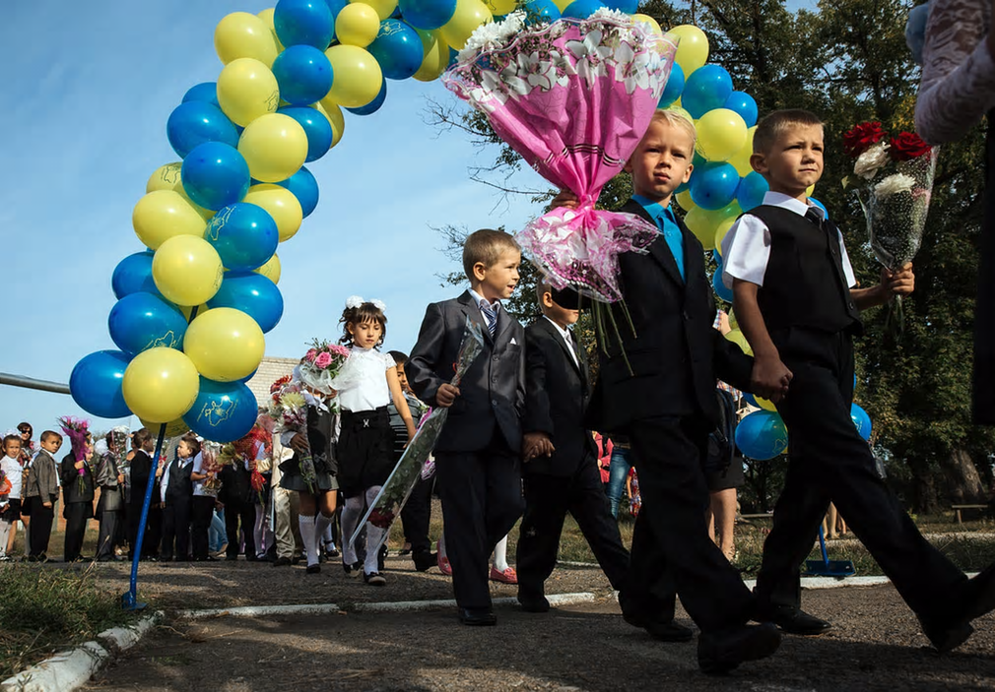

The first day of the schoolyear is celebrated this way in the Ukraine.
Welcome!
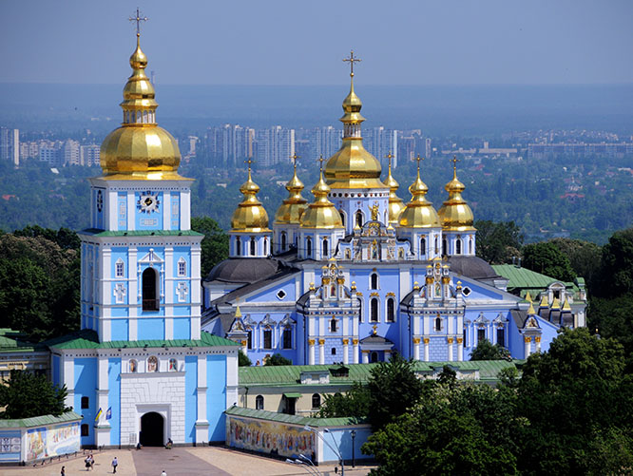

Laskavo prosymo!

