  - What is Colourful Semantics
Colourful Semantics is a speech and language therapy technique that helps children develop their sentence structure and storytelling skills. It uses colour-coded cues to highlight different parts of a sentence—such as who (subject), doing what (verb), what (object), and where (place). By visually organising sentences with colours, it supports understanding of grammar and encourages more complex and accurate language use.

At Thameside, we use colourful semantics within our writing as a scaffold to support children to structure and extend their ideas.

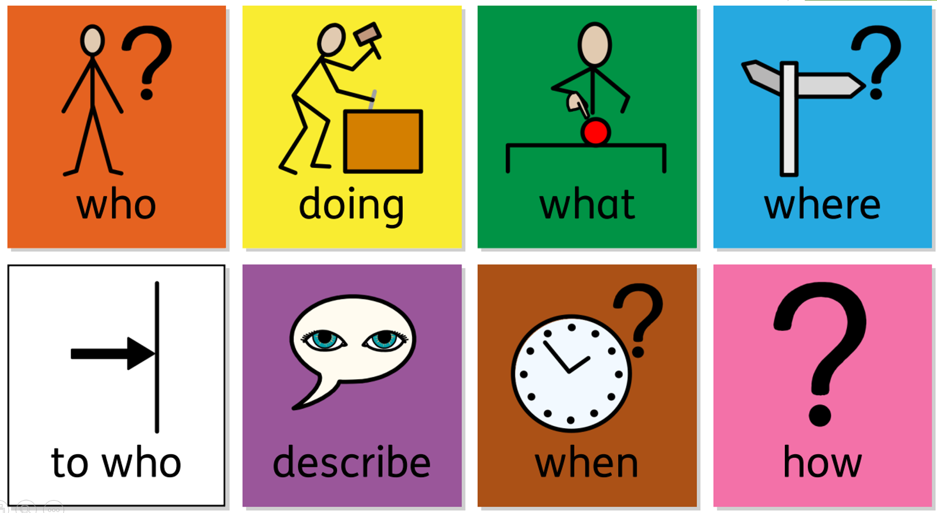


Colourful Semantics

  - How does it work?
- Colourful refers to the colour-coding parts of a sentence. Semantics is to do with the meaning of individual words and how words combine to create meaning in a sentence
- Works in stages, helping children to learn one part of a sentence at a time
- You don’t need to use every colour in every sentence
- The colours can be in a different order to create different sentence structures

