
Ordinarily Available Provision (OAP)
Key facts / Information
This guide is to help everyone better understand what is available in Thameside for children with special educational needs and/or disabilities (SEND) who do not need an Education, Health and Care (ECH) plan but still need specialist support. We call this support the Ordinarily Available Provision (OAP) and it covers everything you can expect to be available for children and young people with SEND in our school.

What is ‘ordinarily available provision’ (OAP)
OAP is intended to answer the ‘when, what, where, why, who and how’ types of questions you may have about SEND support that should be available.

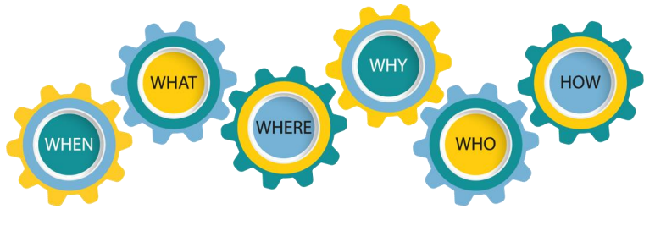

What are Special Educational Needs and Disabilities (SEND)?

Definition and Categories of SEND
Special Educational Needs and Disabilities (SEND) refers to children with learning difficulties or disabilities that make it harder for them to learn compared to most children of the same age. All children learn and different rates and some children may need additional support with their learning.

There are four broad categories of SEND, which include:

Communication and Interaction: Some children and young people have difficulties with speech, language, and communication, which can make it hard for them to understand and communicate effectively with others.
Cognition and Learning: Some children may have difficulties with organisation and memory skills or have a specific difficulty affecting one part of their learning, such as literacy or numeracy.
Social-emotional Mental Health Needs (SEMH): Some children and young people have difficulties managing relationships with others, regulating their emotions or present as withdrawn (which may reflect underlying anxieties or low mood).
Sensory and/or Physical Needs: Some children and young people have visual and/or hearing impairments or a physical condition that requires ongoing support and specialised equipment.

Children with the most complex needs will be entitled to support through an Education, Health and Care Plan (EHCP). An EHCP may be provided for a child after a series of assessments from a range of professionals have been completed. These are legally binding documents which describe a child’s SEND and outline the special educational support the child should receive. The Local Education Authority (LEA) will provide an Education, Health and care plan if they decide that the additional help a child requires cannot solely be provided from within the school’s resources. Such resources could include money, staff time, training and special equipment.
The remainder of children with SEND will receive SEND Support from the school through interventions and high quality teaching. If a child has specific barriers to learning, support from external professionals might also be needed. Such professionals might include Educational Psychologists, NHS Speech and Language Therapists, Occupational Therapists, Creative Therapists and medical professionals.

Supporting SEND
There are a number of principles underpinning the SEND systems in Thameside. They include the following;
- early identification of needs
- high expectations and aspirations for SEND children's achievements
- involvement from families
- views of the children or young person
- collaboration between professionals i.e. education, health and social care
- clarity of roles and responsibilities
- high quality provision.
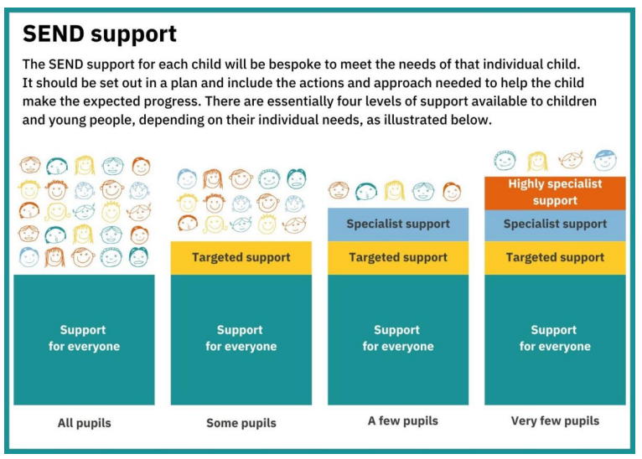

What Ordinarily Available Provision includes:
Quality First Teaching

Quality First Teaching (QFT) is a teaching approach to providing high-quality education to all children and young people with SEND. It ensures that every lesson is effective and accessible. QFT aims to ensure that every child or young person with SEND receives a high standard of education and can achieve their full potential. QFT is recognised as the first step of responding to children and young people with SEND in the SEND Code of Practice.

Here are principles of Quality First Teaching that are seen in our school:

• Inclusive Lessons: Lessons are designed to meet the needs of all children and young people with SEND, including those with different learning styles and abilities. This means using various teaching methods and materials to help every child or young person with SEND understand the content.
• High Expectations: Teachers have high expectations for all children and young people with SEND. They believe every child and young person with SEND can succeed and encourage them to do their best.
• Engaging Teaching: Lessons should be interesting and engaging. They should capture children and young people with attention and make learning enjoyable. This might include interactive activities, group work, and practical examples.
• Clear Objectives: Teachers set clear learning objectives for each lesson. children and young people know what they are expected to learn and why it is important.
• Effective Assessment: Teachers regularly check children and young people’s understanding through questions, quizzes, and other assessments. They use this information to adjust their teaching and provide additional support where needed.
• Differentiation: Teachers adapt their teaching to meet the diverse needs of their children and young people with SEND. This could mean providing extra challenges for advanced learners or additional support for those who are struggling (scaffolding).
• Feedback: Teachers provide constructive feedback to children and young people with SEND, helping them understand what they did well and how to improve. This feedback is specific, timely, and focused on helping them progress.
• Positive Learning Environment (Inclusive Classrooms): The classroom environment is supportive and positive. Teachers build good relationships with children and young people with SEND, encourage mutual respect, and create a safe space for learning.
• Professional Development: Teachers continuously seek to improve their skills and knowledge through ongoing professional development.

