
SEND Team on A4
Name | Role | Contact details | Photo
Mrs Charlotte Harkins | Assistant Head for Inclusion  SENDCo lead for Years 3-6 | inclusion@thameside.reading.sch.uk | 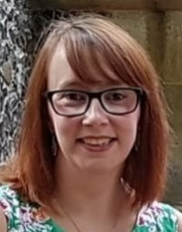
Mrs Charlotte Muldoon | SENDCo  SENDCo lead for ARPs | cmuldoon@thameside.reading.sch.uk | 
Mrs Rachel Thomas | SENDCo  SENDCo lead for Years FS-6 | rthomas@thameside.reading.sch.uk | 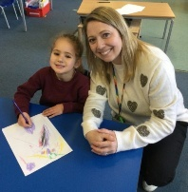
Miss Ciara Finn | SEND and ARP teacher | Contact via school office or SENDCos
Miss Sophie Roseaman | ELSA | familyhub@thameside.reading.sch.uk | 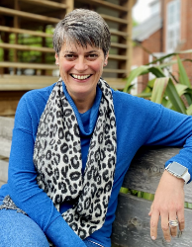
Lata Parbhoo | SEND governor | Contact via school office or SENDCos
Abigail O’Neill | Educational Psychologist | Contact via school office or SENDCos | 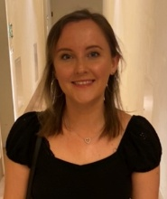
Anna Woolston | Speech and Language Therapist | Contact via school office or SENDCos
Yasmeen Floodgate | Play Therapist | Contact via school office or SENDCos | 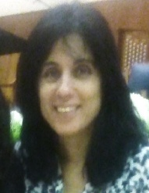
Sarah Vugler | BEAM Drawing and Talking Therapist | Contact via school office or SENDCos | 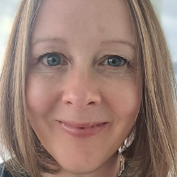
Emma Burridge | Teacher of the hearing impaired | Contact via school office or SENDCos
Nicoleta Carnuta | Teacher of the visually impaired | Contact via school office or SENDCos
Julie Calce-Bunker | Teacher of the visually impaired, habilitation specialist | Contact via school office or SENDCos

