
Waves of Provision on A4
Key facts / Information
What are Thameside’s ‘Waves of Provision’?
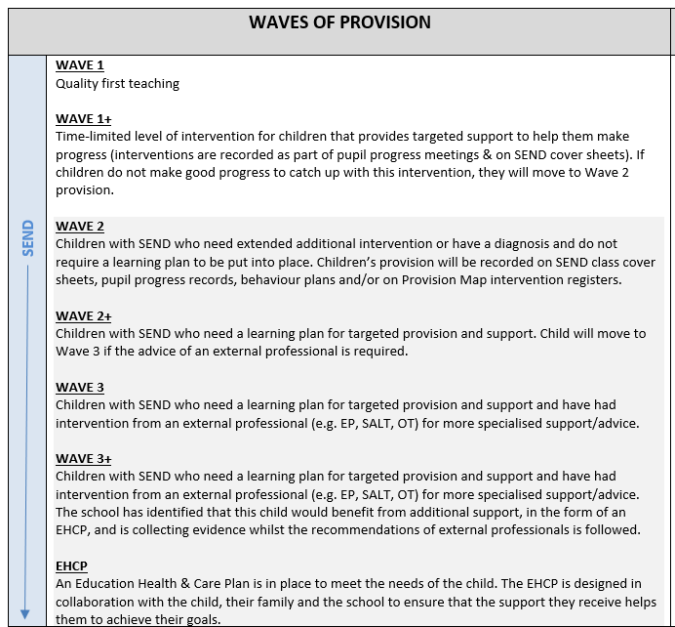

Key facts and information:
- ‘Waves of Provision’ are how we assess the support that a young person at Thameside needs in order to be successful and make the most progress possible. Children can move between the different waves as their needs change – it is not a fixed position. We are not diagnosing children with any SEND need by placing them on the ‘Waves of Provision’.
- Teachers and SENDCos will regularly discuss the children in each class to ensure that the support they are receiving is what they need.
- If a child is accessing an intervention (e.g. ELSA), then they will not be able to access another until that first intervention has concluded. This is to ensure that we can assess the impact of the intervention.
- Children on Wave 2+ and above will have a learning plan on Provision Map. This will be updated in the termly SEND reviews by the teachers and SENDCos. Parents/carers are able to access their child’s Provision Map to see what support is being put in place for them. Parents/carers can leave comments on how they feel their child is progressing against the targets that have been set on the learning plan.

Sources of support
We would encourage any parent/carer to speak to their child’s class teacher or SENDCo about the support their child is receiving. You can find the email addresses of all the SENDCos on the school website, alongside Thameside’s Whole School Provision Map which outlines examples of support that may be given in each wave if you would like to find out more.

