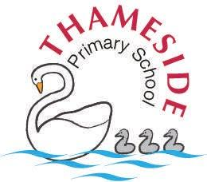
My Name:
What’s important to me…

- My family especially my two sons.
- My chocolate Labrador called Harley.
- Being there for others.
- Fitting in and being a team player.
- Smiling and laughing.
- Making people happy.
- Socialising.
- Food!

What people like and admire about me…

- Caring and Trustworthy.
- Always put others first.
- Kind and considerate.
- Thoughtful.
- Helpful.
How best to support me…

- Take time to chat.
- Listen.
- Respect
Miss K Woods



