My Name:
What’s important to me…

- Being able to spend time with my family.

- Being a teacher!

- Having the opportunity to be creative – drawing, painting, and baking.

- Catching up with friends over tea and cake.

- Being part of a team.

- Doing a good job.

- Going for long walks and enjoying the outdoors.

- Curling up with a good book and a hot chocolate.

- Singing along to my favourite songs in the car.

How best to support me…

- Encouragement and praise.

- Being a good listener.

- Bringing me chocolate or tea.

- Let me write things down so I don’t forget.
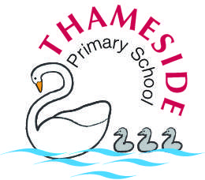
Mrs Marchmont

What people like and admire about me…

- I work hard and always strive to do my best.

- I’m a good listener.

- My positive attitude.

- My strong performances in a team quiz!



