My Name:
What’s important to me…

- My family and friends.

- My work at Thameside.

- Helping children reach their potential.

- That everyone is having fun.

- Doing everything to the best of my ability.

- Coffee and chocolate.

- Being out in the fresh air, especially being near the sea.

How best to support me…

- Show kindness and respect to everyone.

- Big smiling faces when you arrive in the mornings.

- Challenge yourself to always try your best.

- Keep the classroom clean and tidy.

- Help me find my glasses.
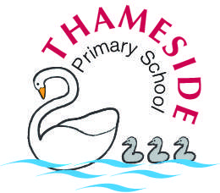
Miss Browne

What people like and admire about me…

- I am hard working, friendly and patient.

- I work well within a team.

- I listen and think before I speak.



