My Name:

What’s important to me…

My family and friends including my 3 children.

Working with children- I have always wanted to work with children and I love being a teacher.

A positive ‘can do’ attitude

Cooking- I enjoy trying out new recipes and exploring foods from different countries and cultures.

Books- I love reading and especially enjoy sharing picture books with my children.

Being outdoors- I love to be outside exploring and enjoying nature. The Lake District is my happy place.

Running and football..

Coffee, cake and chocolate!

How best to support me…

Start each day afresh- come in with a smile on your face and say ‘good morning’ to me. It will brighten my day!

Be respectful- listen when I am talking to you.

Be kind and considerate to everyone, including yourself.

Be positive- Always believe in yourself and try your best.

Help me to help you- Talk to me when you are unsure or need a helping hand.
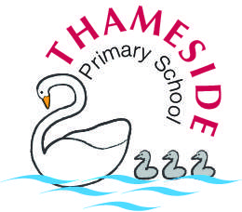
Mrs Cooper

What people like and admire about me…

I am always smiling

I have a good sense of humor

I am a calm and positive person

I am very approachable

