My Name:
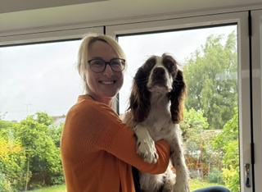

What people like and admire about me…
- I always find positives in every situation.
- My enthusiasm and energy.
- My ability to connect with people.
- I am a black belt in Shukokai Karate and Wu Shu Kwan Kickboxing.
- My thirst for travel, adventure and adrenaline sports.
- My kind, caring and thoughtful nature.
- My determination, I never give up!

What’s important to me…

- My family, especially my two daughters.
- My Springer Spaniel Obi, my best friend!
- My friends, who are always there for me and bring out the best in me.
- To be the best teacher I can be, to all children in my care.
- That everyone’s differences are valued, understood and celebrated.
- That I build strong, trusting relationships with my colleagues, pupils and their families.
- That I make learning engaging and fun.
- Helpings others.
- Spreading my love of languages to all the children I teach.
- My job at Thameside Primary School. I am excited to be part of your community.

How best to support me…

- Be open and honest with me and talk to me about your worries; that way, you are helping me, to help you.
- Be kind, be curious, be respectful and show you care.
- We are a team! Let’s work together!
- A smile, a kind word and some dark chocolate is the best recipe to cheer me up on a difficult day.

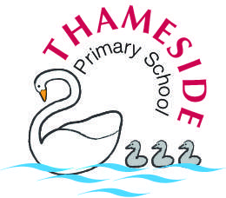
Mrs Baillie

