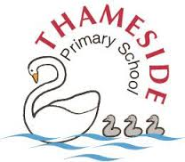

Reading Policy and Guidelines
2026-2027

S Greenaway, S Cooper, C Calvert

Reading Policy and Guidelines
Teaching children to read is fundamental to all other activity that takes place in the classroom. It demands our time, energy, and commitment.
A teacher who loves reading
Even the most finely-crafted reading lesson will miss the mark if the teacher is not enthusiastic about reading. All this will come more naturally to someone who reads and understands books themselves. A national project based on ‘Teachers as Readers’ revealed that teachers who were readers “made a positive impact on children's desire to read and frequency of reading at home and at school” and showed that attainment was positively impacted as a result.
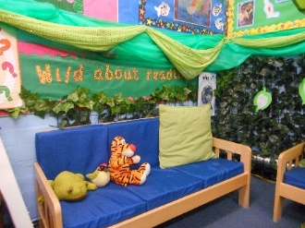
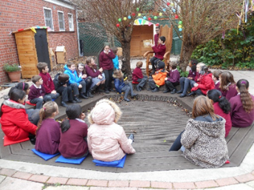
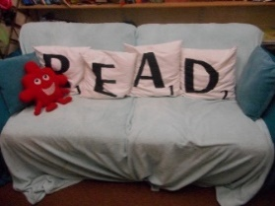

Principles of the teaching of reading at Thameside
These guidelines have been written to ensure that every child within the school becomes a reader.

Teaching a child to read is a simple ask, but a complex undertaking.

The Simple View of Reading (from the EEF) provides a helpful point from which to understand that complexity. Breaking down to its component parts, the model highlights that successful reading is a product of two complex, but separable processes:
- Word reading: The ability to recognise, decode and understand the meaning of individual written words.
- Language comprehension: A multidimensional process that is used to access the underlying meaning of spoken and written language. This involves the integration of multiple sources of knowledge and skills, including knowledge of word meanings and syntax, and making inferences (for example, drawing on background knowledge as we listen and read).
There is the need for a balanced approach to the teaching of reading. At Thameside, we understand the importance of word reading through systematic teaching of phonics. We also focus our attention to the development of comprehension of the spoken and written word. 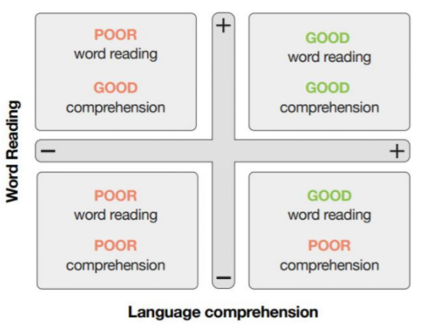

Like in most primary schools, the teaching of phonics at Thameside is a priority. Without the foundation of decoding, reading simply doesn’t develop.
However, the goal of reading is to comprehend what we read, so we also have to develop our pupils’ reading fluency. Additionally, reading comprehension strategies offer a further thread to strengthen our pupils’ ability to go on to confidently comprehend what they read.
Hollis Scarborough’s ‘reading rope’ (below) helps remind us of the many different threads that are essential to develop our pupils as skilled readers at all key stages. Tending carefully to each thread in the rope matters if we are to weave a strong reading rope in every classroom.

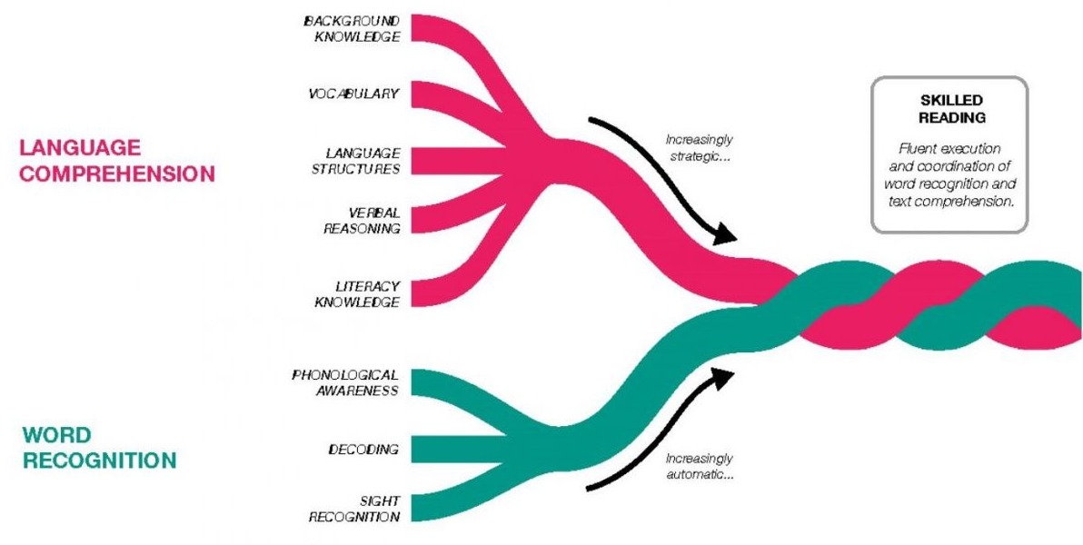

Reading should be an enjoyable experience, and allow children to develop both their imagination and their vocabulary.
Independent readers should be encouraged to read for a sustained length of time allowing them to become ‘lost in a
book’. Children must also read in order to access the curriculum in all key stages. Reading is vital for future learning.

Baseline data shows that many children enter this school with low levels of language, phonological awareness, and
independence. They can present as passive children who are not involved in their own learning. Therefore, we have to find
a way of reaching these children, as there is no real reason why they shouldn’t learn to read. School ethos, expectations
and commitment to Assessment for Learning, ensures that children can become independent and motivated. Success
through reading is the greatest motivator of all.

The programme for early readers is almost entirely based on phonics using the Read Write Inc programme to develop phonic knowledge and fluency. In Read Write Inc. phonics lessons, children learn to read accurately and fluently with good comprehension.

Reading in groups is based on continuous assessment of need, phonic books are closely matched to children’s increasing knowledge of phonics and ‘tricky’ words so that, early on, they experience plenty of success. Repeated readings of the texts support their increasingly fluent decoding.

Children should be taught to both comprehend and love books at Thameside.

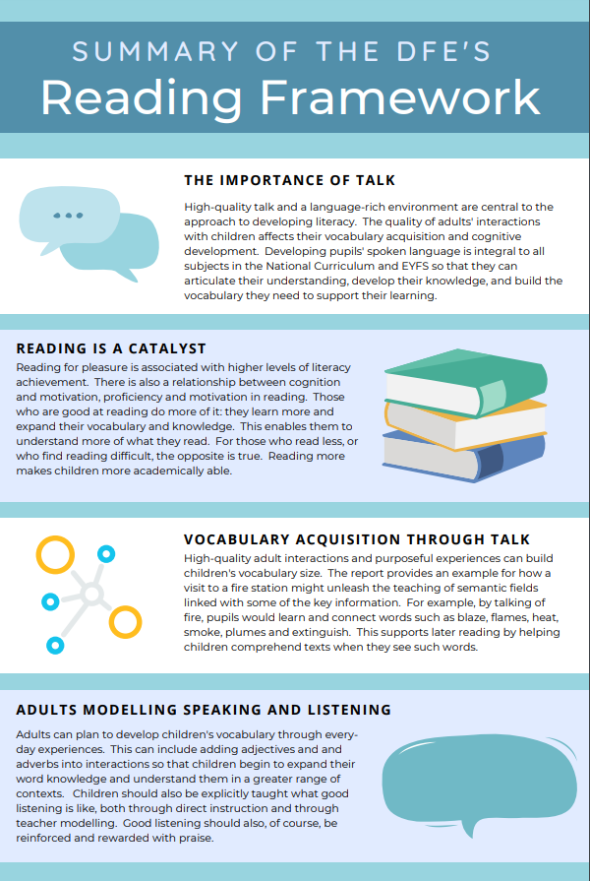

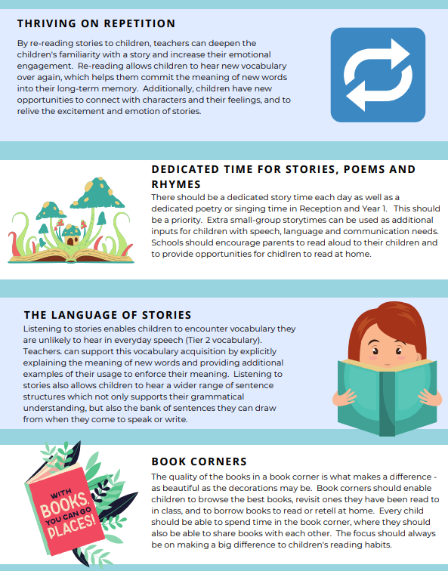

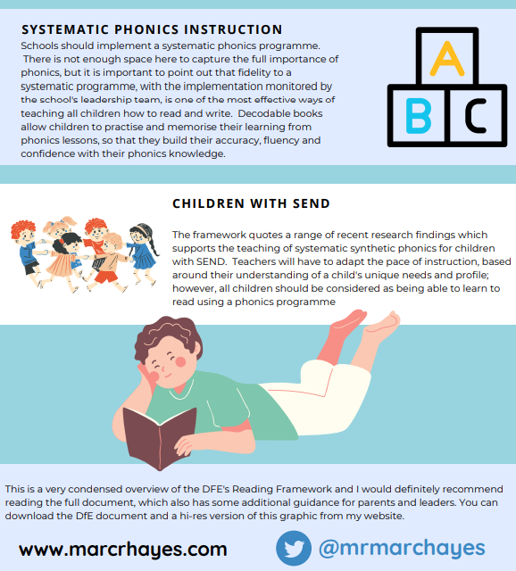

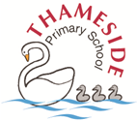
Phonics at Thameside on A4
Design/Intent
(or what we’re moving towards and why)

At Thameside, we believe that every child has the ability to read accurately and fluently with good comprehension. RWI phonics teaches children to decode words by sounds, rather than recognising whole words. Children are taught the letters (graphemes) that represent these phonemes and also learn to blend them into words.

Implementation
What might you typically see?
- In KS1, all phonics will be recorded in phonics books from the start of the year
- In FS, children will record in books when appropriate (but all by the end of the year)
- Resources which are appropriate to each group e.g. green word cards, frog puppet
- The RWI speed sound lesson plan pdf will be followed and used as a script in each session
- Children will be taught phonics in differentiated ability groups which are reviewed half termly by class teachers after a phonic assessment
- Experienced phonics teachers teaching the lowest 20% of the cohort in FS and KS1
- When writing sounds on a whiteboard, they will always be modelled by adults in school hand (cursive from blue group)
- Adults using appropriate sized sound cards for their group
- Teachers will fill in their own medium term plan using the blank pro form provided from assessment information
- Adults taking responsibility and ownership for their own phonics resources
- Fast paced teaching where progress is easily seen
- Sessions which include a range of activities enabling children to revise their knowledge, learn new sounds and apply and practise their skills
- Use of silent signal to limit teacher talk
- Resources set up and prepared for the lesson
How the school intervenes swiftly to help those having difficulty to make sure they keep up, and to stretch and deepen the learning of the ‘rapid-graspers’:
- All children should access 45 minutes or more of phonics daily (this may be split into smaller chunks throughout the day)
- All children in the Foundation Stage have a phonics input every day
- All children in Year 1 have a daily phonics input until they reach the comprehension group where they will go on AR and do daily Guided Reading
- All children in Year 2 who did not pass the phonics screening in Year 1, join a phonics group for a daily input
- Children in KS2 who need to can still access phonics sessions as well as 1:1 tutoring or Fast Track Tutoring
- Across FS and KS1, children identified at pupil progress meetings as being below ARE or not making enough progress in phonics will have 1:1 tutoring, phonological awareness activities and use the phonics virtual classroom.
- Once children complete the RWI scheme they will move to AR and do daily Guided Reading
What won’t you see?
- Children unengaged in phonics
- Inconsistency in teaching
- Mixed ability groups
What opportunities are there for intelligent practice of knowledge and skills?
- Daily 1:1 reading interventions
- Writing across the curriculum
- Enrichment activities linked to reading and writing where phonetic knowledge will be applied
- Extra-curricular activities involving reading and writing
- Day to day tasks and activities
- Phonics in the environment

Impact on knowledge and skills
Assessment information is used to improve pupil knowledge and skills.
Formative assessment

- Immediate feedback (post it notes) and pinny time are used so that teachers intervene swiftly to help children who are struggling
- Assessment takes place daily and is used to identify individual needs and to inform future planning (post it notes, update medium term plan)
- Half termly phonics assessments using Ruth Miskin resources

Summative assessment
- All children taking part in daily phonics sessions (FS, Year 1 and some Year 2 children) will be screened half termly using Ruth Miskin resources
- All Year 1 and those children in Year 2 who have not yet passed the phonics screening, will be assessed termly using past phonics screening materials to track progress

The assessment assesses the child’s understanding of:

- Recognition of phonemes/graphemes
- Ability to blend and read words (including alien words)
- Ability to segment and spell words (including alien words)
- Recognition of high frequency words (red words)
- Fluency of reading
At the end of Year 1 there is a statutory assessment (Year 1 phonics screening check) which usually takes place in June each year. Parents are informed of the outcomes of this check. Those children that do not achieve the pass standard have the opportunity to retake the test in Year 2.
Learning to read at Thameside on A4
Design/Intent
(or what we’re moving towards and why)
Reading should be an enjoyable experience, and allows children to develop both their imagination and their vocabulary. Independent readers should be encouraged to read for a sustained length of time allowing them to become ‘lost in a book’. Children must also read in order to access and make progress across the whole curriculum both in Key Stages 1 and 2. Reading is vital for future learning.
Baseline data shows that many children enter this school with low levels of language, phonological awareness, and independence. They can present as passive children who are not involved in their own learning. Therefore, we have to find a way of reaching these children, as there is no real reason why they shouldn’t learn to read. School ethos, expectations and commitment to Assessment for Learning, ensures that children can become independent and motivated. Success through reading is the greatest motivator of all.
The programme for early readers is almost entirely based on phonics using the Read Write Inc programme to develop phonic knowledge and fluency. In Read Write Inc. storybook lessons, children learn to read accurately and fluently with good comprehension.

Implementation
What might you typically see in a Storybook session:
- Children will be taught in differentiated ability groups which are reviewed half termly by class teachers after a phonic assessment
- Experienced phonics teachers teaching the lowest 20% of the cohort in FS and KS1
- Children reading books matched to the phonics sounds they are taught
- Thought provoking story introductions
- Prompts used to encourage thinking out loud and discussion
- Teachers modelling reading
- Children reading red and green words
- Children reading the same story three times
- The first read developing accuracy
- The second read developing fluency
- The third read developing comprehension
- Oxford Owl e-book assigned at the beginning of each week (same book as reading in school)
- Teachers to read 1:1 with all children once a fortnight (3 children per day)
- TA to hear additional readers that need more regular reading practice (children identified in pupil progress meetings)

How the school intervenes swiftly to help those having difficulty to make sure they keep up, and to stretch and deepen the learning of the ‘rapid-graspers’:
- All children in the Foundation Stage from red ditty group up have a storybook session every day
- All children in Year 1 have a storybook session every day
- All children in Year 2 who did not pass the phonics screening in Year 1, join a Year 1 phonics group for a storybook session
- Across FS and KS1, Years 3&4 children identified at pupil progress meetings as being below ARE or not making enough progress in phonics will have 1:1 tutoring, phonological awareness activities and use the phonics virtual classroom.
- In Years 5&6 children identified at pupil progress meetings as being below ARE or not making enough progress in phonics will have Fresh Start tutoring and use the phonics virtual classroom.

What won’t you see?
- Children unengaged in storybooks
- Inconsistency in teaching
- Mixed ability groups

What opportunities are there for intelligent practice of knowledge and skills?
- Fluency for reading and storytime
- Writing across the curriculum
- Enrichment activities linked to reading and writing where phonetic knowledge will be applied
- Extra-curricular activities involving reading and writing
- Day to day tasks and activities
- An Oxford Owl e-book assigned to children weekly based on the sounds they have been taught that week
- Additional book bag books sent home

Impact on knowledge and skills
Assessment information is used to improve pupil knowledge and skills.
Formative assessment
- Immediate feedback used so that teachers intervene swiftly to help children who are struggling
- Assessment takes place daily and is used to identify individual needs and to inform future planning
- Termly assessments using Ruth Miskin resources

Summative assessment
- All children taking part in daily storybook sessions (FS, Year 1 and some Year 2 children) will be screened termly using Ruth Miskin resources

The assessment assesses the child’s understanding of:
- Ability to blend and read words (including alien words)
- Recognition of high frequency words (red words)
- Fluency and accuracy of reading

Learning to Comprehend at Thameside on A4
Design/Intent
Successful reading is a product of two complex, but separable processes:
- Word reading: The ability to recognise, decode and understand the meaning of individual written words.
- Language comprehension: A multidimensional process that is used to access the underlying meaning of spoken and written language. This involves the integration of multiple sources of knowledge and skills, including knowledge of word meanings and syntax, and making inferences (for example, drawing on background knowledge as we listen and read).

Learning to comprehend at Thameside Primary School is inspired by Talk for Reading to help children to read critically, appreciatively and confidently. For maximum impact, our intent is for children to learn to read age/stage appropriate texts, learn to comprehend age/stage appropriate texts and read for pleasure because that is the culture instilled by our school.

Implementation
What will you typically see in Whole Class Reading lessons?
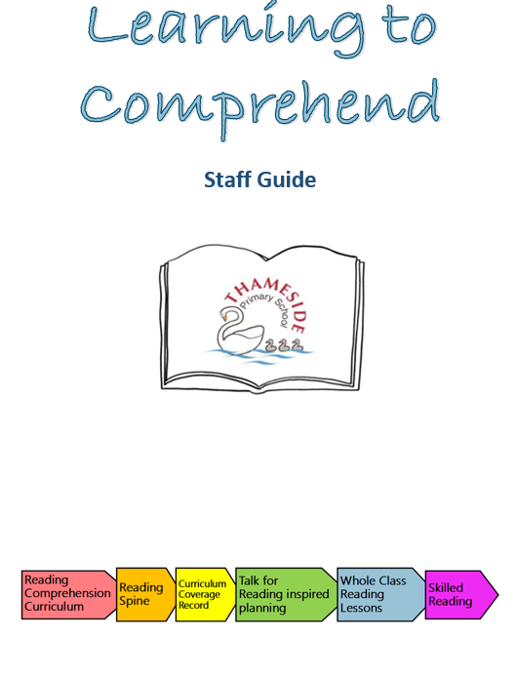
- Staff teaching according to the sequence set for Learning to Comprehend lessons in our bespoke staff guide
- Staff using techniques as laid out in Thameside’s Reading Policy & Guidelines Booklet
- Staff teaching using the correct book from the Reading Spine
- Children evidencing work in whole class reading books, taking care with their presentation
- A large emphasis on the teaching and learning of words, especially tier 2
- Teachers modelling written responses to the big questions and as appropriate
- Children who can use thesauruses and dictionaries proficiently, including Lexipedia
- Thameside word class colours being used when annotating texts
- Inviting book corners and boxes
- Timetabled reading for pleasure opportunities with fluency lessons taking place for children who need them
- Children exploring topics or themes in reading lessons that they are learning about in other subject areas – they are encouraged to make links/connections to other/prior learning
- Children enjoying a wide variety of texts including: picture books, fiction, non-fiction and poetry
- Teacher may use more than one book at a time in reading lessons e.g. Snow Goose (fiction) and Circle (non-fiction) so that children have deeper knowledge and understanding of real-life phenomena
- Children making links between books/texts/subjects/characters/themes (including abstract nouns e.g. hate, hurt, love and characters who are lonely, for example)
- Children being exposed to texts related to relevant Personal Development issues e.g. friendship, healthy living, families, diversity
- Oral book recommendations at the end of units
- 1000+ extracts being used once a week in Year 6 (from specially chosen books with Lexile counts of over 1000)

What else might you see?
- Teachers reading with every child 1:1 once a fortnight (3 children per day)
- TA to hear additional readers that need more regular reading practice (children identified in pupil progress meetings)
- Paired Reading
- Use of resources from Vocabulary Ninja or Literacy Shed Plus
- Focus texts in English lessons
- Word Aware in Foundation Stage
- Teachers reading to their class daily
- Books being used in whole school assemblies
- Book talk in English lessons and use of high quality texts as the basis of writing lessons
- Children making reference to what they have learnt in Whole Class Reading in other lessons e.g. science, history
- Children using books from topic boxes in foundation subjects
- Children making good use of their timetabled library slot and enjoying exploring books
- Children wearing their Millionaire Club badges with pride
- Staff actively involved in special book days to encourage a love of reading
- A school community with a strong reading culture, who love books

What opportunities are there for intelligent practice of knowledge and skills?
- Reading opportunities across the Thameside curriculum to make progress in other subjects through reading
- AR quizzes
- Own-work research

- Children magpie-ing ideas from books to use in their own writing
- Parents volunteering to read in classes and reading to children in other languages

How do children catch up in reading?
- Phonics or Fresh Start intervention
- Readers Theatre intervention
- They read more often with adults
- Nessy & Symwriter to support accessibility
- Adapted texts for children with disabilities
- Encouraged to read for pleasure
- Learning broken up into smaller chunks / scaffolded
- Being exposed to high quality discussions about texts
- Teaching and learning of tier 2 words

Impact on knowledge and skills
Assessment information is used to improve pupil knowledge and skills.
Formative assessment
- AR quizzes
- Whole Class Reading discussions and performance in independent activities
- Ability to use reading to make progress (know more, remember more, do more) across the Thameside curriculum offer
Summative assessment
- Accelerated Reader Star Reader Tests
- Optional SATS in Years 3-5 are used in Term 5 & SATS in Year 6

Expectations at FS and KS1
For pupils to attain at National Expectations at the end of KS1, the following must happen;

Pupils must leave Foundation Stage in RWI green group.

Pupils must leave KS1 reading in RWI yellow group

End of Y1 benchmarks:
Emerging - orange and below
Expected – yellow and have passed the Phonics Screening Check
Exceeding - blue and above

End of Y2 benchmarks:
Emerging - grey and below
Expected – Accelerated reader (see Star reader test)
Exceeding – Accelerated reader (see Star reader test)

At each assessment point throughout the year reading leaders will share which step an emerging, expected and exceeding child will be on target tracker.

Teaching of RWI Phonics and Early Reading
All children will be taught daily for 45 minutes using the Read Write Inc. lesson plans for Speed Sound lessons and Storybooks. Children will be assessed daily and moved if necessary, they will be formally assessed by Phonics and Reading leaders half termly and regrouped. Teachers must use the ‘What to Teach When’ document found on the Oxford Owl website or saved on common (Thameside Primary School\Common - P\PLANNING\7. CORE SUBJECT RESOURCES\PHONICS\2026-27\Planning) and record the sounds they have taught daily on the record sheet in phonics boxes.

Phonics
Phonics is the primary aspect of reading and is promoted above all learning to read strategies. At Thameside, we use the RWI scheme to teach phonics.

Phonological awareness is a pre- requisite for reading, this will be taught explicitly for children beginning the scheme or working below. Children in Reception should be introduced to sounds in words through ‘Fred Talk’, eg ‘s – i – t’ sit down’ etc. Older Reception children should start to be formally taught the sounds of the letters of the alphabet, and how to blend and segment.

The order of teaching should be as follows.
Speed sounds set 1
m a s d t i n p g o c
k u b f e l h sh r j v y
w th z ch q(qu) x ng nk ck

Speed sounds set 2
ay ee igh ow oo oo oar
or air ir ou oy

Speed sounds set 3
a-e i-e o-e u-e ea aw are ur
er ow ai oa ew ire ear
ure tious tion
wh ph kn au e-e ie ue

For further information, please see;
Read Write Inc; ‘Speed Sounds Lesson Plans – Handbook 1 & 2’ Ruth Miskin Oxford Owl Website

Phonics 5 Day Timetable
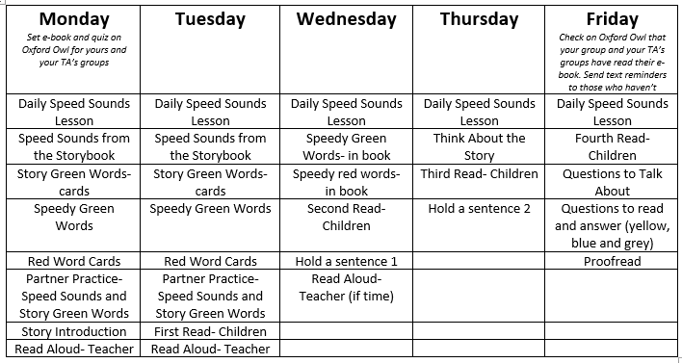

Yellow groups and above to have a shorter daily speed sound lesson and greater focus on story books and fluency. On a Friday children will complete SATs style questions on the book.

Daily Speed Sound Lesson (using ‘ay’ as an example
Read the sound Say the sound
- Say the sound ay (without showing card)
- Show the speed sound card picture (picture side) and explain the picture e.g. This little girl wants to play. She says…may I play?
- Say “ay – may I play?” and ask children to repeat
- Say one of the words listed on the speed sound card in Fred Talk – ask children to repeat in Fred Talk and then say the whole word. Repeat for 3 – 4 words

- Show the speed sound card (picture side) – when we look at this side we say “ay – may I play?”
- Show the letter side – when we look at this side we say “ay”
- Explain that when we have two or more letters together they make just one sound e.g. ay. Explain that these are special friends
- Point to the sound on the Simple Speed sound poster and say the sound
- Flip the card a few times and ask children to say the sound or the phrase
Review sound
- Hide sound in pack of sounds taught so far. Include some set 1 sounds which need practice. Ask children to read sounds and spot new sound
Word Time
- Use the phonics green word cards listed – spray, play, day, way, may, say
- Hold up the first card (dots and dashes side) e.g. spray – ask children to tell you the sound of the special friends e.g. ay
- Ask children to Fred Talk e.g. s-p-r-ay and then say the word ‘spray’
- Adult says the word with exaggerated pronunciation. Ask children to repeat.
- Repeat with all words

Review the words (already taught from previous set 2 lessons and 1.6 and 1.7 word time words)
- Ask children to read the words without the dots and dashes for all words
- Ask children to tell you the special friends or to shake their heads if there are not any
- Ask children to say the sounds in Fred Talk and then read the word
- Use Fred in Your Head to gain speed
Reading assessment
- Ask children to read a few alien words that with sounds already taught
- Show the word and ask them to tell you the sound of the special friends or to shake their shake if there are no special friends
- Ask children to say the sound and read the word
Spell with Fred Fingers
- Say the word e.g. spray and ask children to repeat it
- Ask children to:
- Hide their fingers as they count the sounds on them
- Hold up their fingers, palms facing them, when you say fingers
- Repeat the word, then pinch their fingers as they say the sounds, e.g. s-p-r-ay
- Write the word as they say the sounds, underlining any special friends
- Ask children to say the sounds as you write the word on the board, underlining any special friends
- Ask children to tick/fix the spelling of each sound in their own work
- Repeat with 2/3 words from the list provided
Spell review
- Ask children to write 2 or 3 previously taught words using the steps in ‘spell with your Fred Fingers’
Final challenge
- End with one final challenge to check children can read the new sound
Storybook Lesson
Speed sounds from the story – On the bus (as an example)
- Find the circled graphemes on pg. 4 of the story book. Point to each grapheme on the Simple Speed Sound poster and use MTYT
Story Green Words
- Start hard – select the hardest Story Green words first:
Names and single-syllable word:
- Hold up the card ‘black’. Ask the children to tell you the special friends (ck) or to shake their heads if there are not any.
- Ask children to say the sounds b-l-a-ck and then say ‘black’
- Say the word ‘black’ using pronunciation that gives the word meaning (where possible). Ask children to repeat
- Explain the meaning in the context of the story if an unfamiliar word
- Ask the children to read the word again without MTYT
- Repeat for other words

Root words and suffixes:
- Fold the card jumping so that you can only see the root word (jump) and hold it up. Ask children to read it in Fred Talk first and then read the word
- Unfold the card and ask children to read the whole word with the suffix
- Say the word ‘jumping’ tweaking the pronunciation if necessary, and using pronunciation that gives meaning, where possible. Ask children to repeat
- Explain the meaning in the context of the story
- Ask children to read the word again without MTYT
- Repeat for other words
Speedy Green Words
- Display first speedy green word
- Fred in your head then ask children to say the word aloud when you push the word forward
- Repeat with other speedy green words
- Review speedy green words from other story books
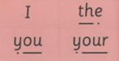
Red Word Cards
- Found in the blue box within your phonics box
- Display the first word e.g. your
- Say the word and ask children to repeat it
- Point to card and say the sounds you can hear e.g. y-or and say your – ask children to repeat
- Point out the tricky letters ‘our’
- Ask children to read the word again (without MTYT)
- Repeat for other Red Words
Partner Practice
- Children practise the speed sounds and story green words
- With a partner, children have 1 book between 2 and lolly sticks for pointing
- Ask one partner to teach the sounds out of order using MTYT
- Ask the other partner to teach the words out of order using MTYT
- Adult to note any sounds/words that need further practice
- Next, children practise the Red Words
- Repeat until they can read all Red Words at speed

Story Introduction
- Adult to read story introduction to children using expression (printed from Oxford Owl website)
- Ask children to turn to their partner to ask the question at the end of the introduction
First Read Children
- Partners need to sit next to each other with a lolly stick
- Choose a partner 1 and a partner 2
- Partner 1 points to the words in the story on the first page whilst partner 2 reads it
- Remind children to prompt their partner to use Fred Talk
- Swap roles for the second and third page
- If children finish quickly they need to re-read the story
- Note any words that need further practice

Second Read Children
- Ask partners to read the whole story again, taking turns to read each page
- Ask partner 2s to point on the first page this time
Third Read Children
- Ask partners to read the whole story again, taking turns to read each page
Read Aloud Teacher
- Children close their story books then read the book to children with expression
Questions to Talk About
- Read out the relevant questions on page 15 of the Ditty Book
- Children to turn to their partner and discuss
Think about the story
- Adult to re-read the story displaying the pictures as you read
- Adult to model thinking out loud about the story for children to listen to e.g. thinking aloud about who is sitting on the bus
- MTYT – the big red bus
- TOL – about what the animals are doing on the bus
- TOL – about who else is on the bus
- TTYP – would you like to travel on such a noisy bus? Why or why not?

Hold a Sentence
- Use the selected sentence for each book from Oxford Owl
- Say the sentence and ask children to repeat it
- MTYT until children remember the whole sentence and then add punctuation mimes
- Write the sentence on the board and ask children to help you:
- Use Fred Fingers to spell Green Words
- Think out loud about how to spell the Red Word
- Use punctuation and finger spaces
- Re-read the sentence to check it makes sense
- Hide the sentence and ask children to write it in their phonics books
- Ask children to check their sentence
Monitoring
Pupil progress will be tracked using Target Tracker. In addition to this, reading leads will update the Ruth Miskin tracker on the school portal. Progress will be discussed at termly Pupil Progress meetings. Pupils identified not to be making good progress must have 1:1 tutoring implemented.
Reading for Pleasure
To encourage reading for pleasure children will also take home a library book and a book bag book. Children have reading for pleasure timetabled daily and can choose which books they would like to read. Teachers can alternate between silent reading, shared reading, recommending books and children reading to the class. This is a good time for teachers to read books with the children and also model good reading habits.
Reading Stories
To develop imagination, vocabulary and a love of literature children should have a rich curriculum of high quality stories. In FS and KS1 stories should be read at least daily with other opportunities used across the curriculum. Please see your year group’s Reading Spine to know which books each year group must hear.

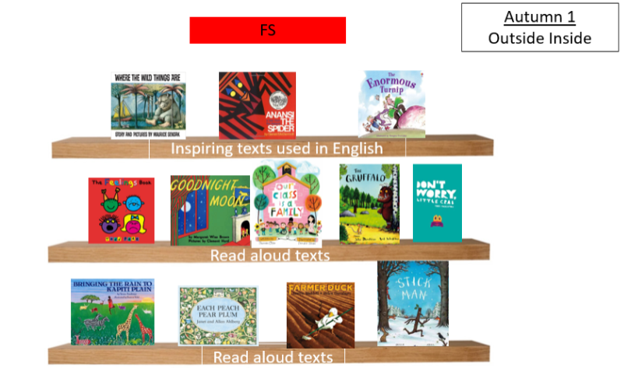

When reading stories, ensure that children are grouped together in front of you ‘find a space, fill a space’. Children should sit still and must listen allowing others to listen too.

Longer books should be read to the older children. Stopping at a ‘cliff hanger’ will develop their curiosity and build up anticipation for the next episode. Children can understand books at a higher level than their own reading ability and this will also support their vocabulary development.

Use the weekly library session to foster a love of books and take the opportunity to end the session with a story.

Reading record
Reading records should be kept in the plastic wallet with the reading books and should be in good condition. Please replace tatty or lost diaries.
Teachers/TAs must keep a track of how many times a child has read at home each week. Every 5 reads children earn a stamp. After they get 3 stamps they get a bookmark.
We still expect children to be reading daily at home for 10 minutes and for this to be recorded in their reading record by parents or carers.
Teachers/TAs should send reminder texts if this is not happening.
Teachers/TAs are expected to hear children read daily (this needs to be prioritised based on assessment and the amount they read at home).
All children must be read with within a fortnight.

Foundation Stage
On entry to the Reception class all children will be taught as a whole class for the first 5 weeks of term. They will then be assessed and allocated groups. They will not have a phonics book to take home until they have learnt at least 16 sounds but are encouraged to share their library books and books from home. Teachers should be directing children to the picture books in the library.

Reading/Language Comprehension: Progression Framework
Classes each have a ‘Reading Curriculum Folder’ (hard copy) which contains their Reading Comprehension framework and other useful resources to effectively teach reading comprehension, as referenced in this section of our guidelines.

Teachers are supported in planning for progression and modelling these reading skills through our ‘Progression of Reading Skills’ document which is saved on common and is in their Reading Curriculum Folder for reference too. This document identifies the progress within the 8 different strands of language/reading comprehension (as listed below), pulling together the year by year objectives, to help make the next step more obvious.

Children will be taught these comprehension skills in Whole Class Reading lessons and will then further develop and apply them to make progress (know more, remember more, do more) in other areas of the curriculum.

- Develop positive attitudes to reading

- Skills and Strategies to read for understanding
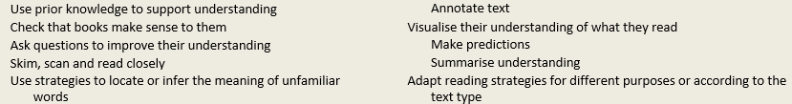

- Understand the vocabulary used in texts

- Express, record and present their understanding

- Understand the whole text

- Retrieve information from texts

- Inferential understanding

- Reading to find out

Reading Spine
The Thameside Reading Spine and its Rationale are updated annually and both are located on the school website: https://www.thamesideprimary.co.uk/page/?title=Our+READING+Spine&pid=110&action=saved

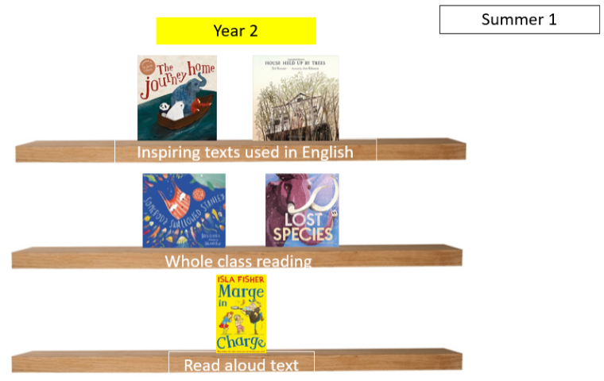

The Reading Spine is a core list of texts that teachers must use in English lessons, Whole Class Reading lessons and as their Class Readers, which MUST be read to children on a daily basis by the teacher.

Class Readers:
Across the school, teachers read a year group text to their class at some point during every day - modelling reading is an essential skill that we encourage. Reading aloud allows children to access high level texts, enables them to hear how unfamiliar language and sentence structures should sound and is proven to aid comprehension of a text. Children also benefit from opportunities to read aloud themselves, which is why we use some children as reading coaches across the school.
All classes have specific texts that have already been chosen as class readers to ensure a consistent approach across the school.

We make sure that children have a label stuck inside their yellow share reading books to indicate which three books they are focusing on that term:
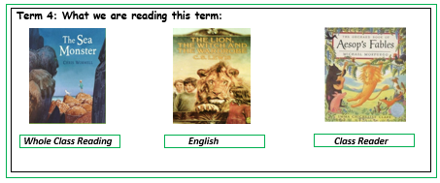

Whole Class Reading / Learning to Comprehend

When planning Whole Class Reading / Learning to Comprehend lessons at Thameside Primary School, staff should refer to our bespoke Learning to Comprehend Staff Guide’.

Key components

A deliberate focus on skills
The Thameside ‘Learning to Comprehend’ sequence of lessons supports this focus on teaching a particular skill from our Reading Curriculum and these guidelines provide additional strategies/ideas for staff on how to do so.

Retrieval examples

Speed Read

An activity which enables pupils to record facts from the text. This can be under time limit so that pupils are able to build on retaining the information as well as their speed.

- Ask pupils to record the most important facts on post it notes. They can then rearrange their ‘important facts’ on the speed read sheet. This can also lend itself to sequencing.

- Have questions on the Speed Read sheet. Pupils can look for answers for questions as they are reading – have they retrieved the correct fact?

- Pupils to record information that may be linked to a specific overall question e.g. why was the character angry? There may be multiple reasons in different parts of the text that answer this one question.

Find the W’s

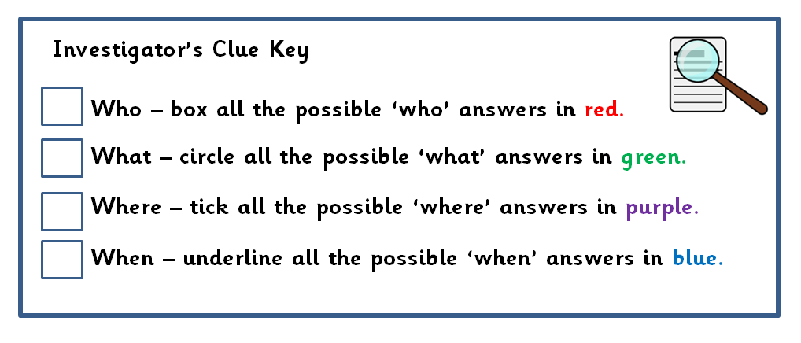
Pupils to look for the different W’s – who, what, where and when. This activity can be broken down into different groups (pairs, tables) looking for different words.

- Pupils could record their words on post it notes and share with another group. They could then write a question which would fit their ‘W’ word.
- Using their ‘W’ words, pupils could create their own true or false statement or match-up questions for a different group or pair.
- Pupils can then feedback to the class where they stand to share their Ws. This can be highlighted on IWB.

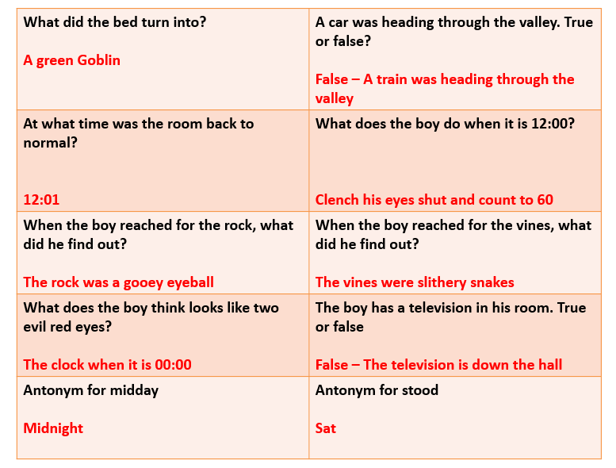
SWAP

Pupils are provided with different retrieval questions. Child 1 will ask the question and child 2 reads the text to find the answer. After this, the Child1 answers Child 2’s questions. When both children have found the answers to the questions they swap the questions and then find another partner with a different question. This continues until all pupils have answered X amount of different questions.

Jigsaw

Pupils discuss facts with their tables. Number pupils 1 – 4 and allocate spaces in the classroom where all the 1s, 2s etc will meet to discuss what they think is the most important fact, what they have discussed on their tables etc. The pupils then return back to their seat to feedback to their group. This is to ensure that all pupils have to participate and be actively involved because they are all expected to feedback to their groups.

Summarising examples

Write the subtitle

Pupils read paragraphs and write a suitable subtitle for that paragraph. The pupils will need to identify the main point of the paragraph thus summarising what they have read.
- Once subtitles have been written, pupils can share their ideas and vote which is the best subtitle and why.

- Teacher could randomly select a subtitle and the class have to decipher which paragraph is being described. If the subtitle is accurate and summarises well then it will be easier to identify the paragraph. This could be something that you draw out from the pupils. Why was it difficult to find the paragraph for this subtitle?

Title writing

Writing titles for a whole text that needs to be concise but accurate.
This could also be:
- A 10 word challenge.
- Write a blurb
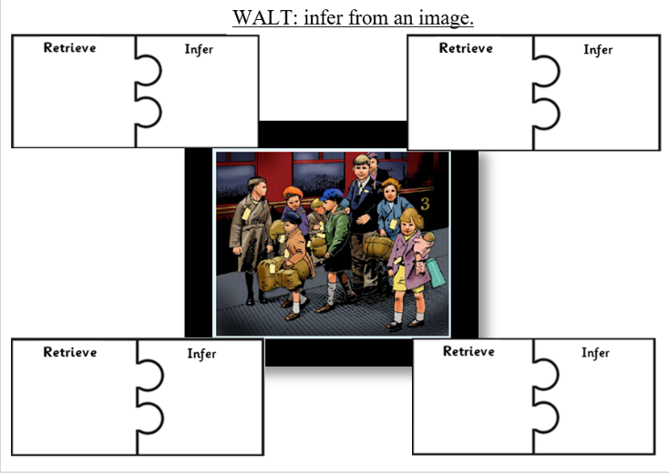
- Comparing titles – which is better and why?

Inference examples

Image jigsaw

Pupils to focus on one image and think about what the image shows (facts that they can retrieve) and what this means (what can they infer). The jigsaw pieces need to be linked and the number of jigsaws can be altered to suit the pupils needs (differentiation).

Make the inference

Give pupils key words (to begin with a place until pupils are familiar with the activity). Pupils work in pairs or groups to create sentences where they must show and not tell what their key word is. This activity enables pupils to think of the inferences. Pupils can then swap with other pairs or groups to find out their key word. For example, key word: shop. There are many shelves which are filled with stock. Music plays in the background as people fill their baskets down the aisles. Where am I?

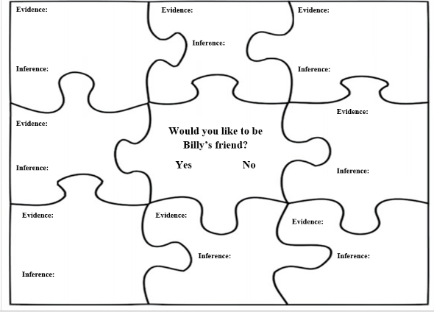
Clue hunt jigsaw

For this activity, pupils read a text and are given an inference question. Pupils fill in the different inference jigsaw with clues which help them create a strong answer with evidence.
- This can be changed so that the answer is already given but pupils need to investigate the text to find the clues.
- It is important that the pupils do formulate and write a final answer to the question at the end of the activity.

Explicit teaching of vocabulary

Our ‘Learning to Comprehend Staff Guide’ directs teachers to complete a Whole Book Overview (WBO) as the initial part of the planning process. The WBO contains a section where teachers select the tier 2 and 3 vocabulary from the text that children need to be explicitly taught so that they are able to fully comprehend the book. This website can support staff to select the vocabulary to teach from the longer texts on their Reading Spines: https://www.vocabulary.com/lists/

Teaching/exploring vocabulary ideas for teachers: NB: See Vocabulary section below for more information on these strategies.

Sematic mapping and word tables

Games
- Countdown corner: challenge to write the correct dictionary definition
- Which definition? Two definitions on the board – one is correct and one is close to being correct. Which one is it and why?

Juxtapose words
For example: Can you make a hesitant declaration? Can you be a kind bully? Can you be a beautiful ugly person?

Visualisation of words/passages/sentences
- Draw what you see/hear

Questioning
Effective questioning has a very important role to play in whole class reading lessons. Alongside effective questioning, we use these ‘Talk Tactics’ from Voice21 to encourage students to think strategically about their contributions to group talk/discussions:

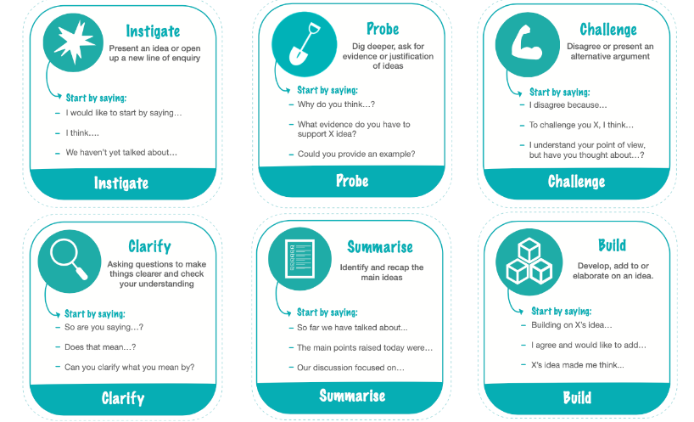

Questioning ideas for teachers:

All you need is 3 questions
- Literal e.g. What can you see? Inference e.g. need to use evidence from the text to answer Explanation e.g. text to world

Quescussion
- Children speak about a picture/text in questions. If a child answers a question, everyone shouts ‘statement’ at them!
- Teacher writes up questions as they are offered. This will give you a long list of children generated questions that you could pick from to explore.

Question quadrants, tables & Book Talk
As a group write questions about the text and lay them out in a quadrant or table (see templates in folder).

Statements
- Start with a statement about the text. Children to agree/disagree/undecided using reasons from the text.

Engaging children in the text whilst teaching the LO/reading skill

Exploring the text ideas:

Reading for enjoyment
Work sequentially – group has a book each and has to turn over pages all together. They can talk about whatever they find interesting.

Silent discussion
- Children have 8 minutes to read and enjoy the whole book but in silence. Then children write any thoughts, feelings, questions on a piece of paper. This is passed on to the next person who responds and so on.

Large scale silent discussion
- Large sheets paper around the classroom with headings e.g. what does the test remind me of; what do I like/not like about the text; what questions do I have etc Children have time to write under each heading in silence.

Speed rating (child B will gather a host of new ideas/thoughts and have more to say about the text)
- Children stand up behind their chairs and face outwards (child A). Another child stands in front of them (child B).
- Child A has 1 minute to tell child B what they wrote about during their silent discussion or what they thought during their silent exploration. Child B listens and then moves around to a new child A, who repeats their information again to a new partner.

Circle of thoughts
- Write down your thoughts in silence about what read and take it in turn to express thoughts round the circle.

Freeze frame and caption

Thought circles
- As we do in writing lessons

Theme cards
- Thinking about themes using evidence form the text

Opportunities for independent written work
In real life, our comprehension of a text is rarely verbalised, let alone written down. But tests that require written answers to comprehension questions are embedded in our education system. As part of our ‘Learning to Comprehend’ lessons, we must prepare children to answer written questions well, so that they have the ability to show the true depth of their level of understanding. We do this through our SATs style DOK challenges at the end of each session.

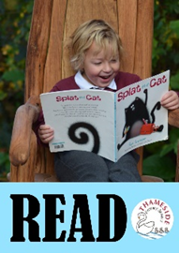

Teaching Vocbulary
Having a good vocabulary is the gateway to understanding – if we don't understand the words we read, then we can’t understand a text. We need to provide children with opportunities to hone skills such as morphemic and contextual analysis. In our ‘Learning to Comprehend’ teaching sequence, we explicitly teach unfamiliar words to the class before the children encounter them in the text.
Our aim from Foundation Stage to Year 6 is to teach robust vocabulary instruction of 2 tier words.
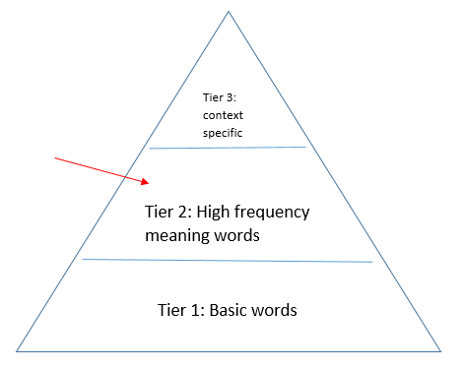

Tier one words are the everyday words that almost all children just know: table, happy, lucky, fast.
Tier three words are specific technical words to a particular area: isotope, piano, volcano; words that children might not know at the start of a topic, but are easily taught and have a fairly fixed definition.
Tier two words, by contrast, are powerful because of the way they carry latent shades of meaning. Distraught is much more precise than sad because it tells us about the degree of sadness. ‘Genuine’ is more complex than ‘real’ because it connotes authenticity, honesty and trust.
How do we teach words?
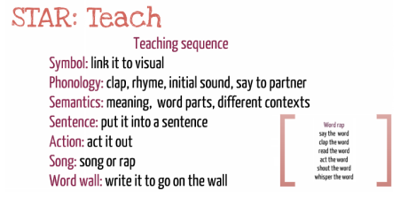
Comprehension skills we need to teach for robust vocabulary instruction
Making connections
Thinking aloud
Visualisation
Predicting
Questioning and question making
Summarising (theme/character)
Seeking clarification
Text marking

Across the school, we use this sequence from ‘Word Aware’ for the teaching of new words.

How else can we teach words?

1. Example/non-example
When discussing the adjective ‘sleek’, a teacher might share a range of nouns in turn, asking pupils to answer ‘smooth man’ if sleek is an appropriate descriptor and saying nothing if it isn’t. So, for example, the teacher might share this list: a porcupine, a duck, a tree, a car.

2. Concrete examples

The teacher supports pupils to generate situations, contexts and examples. How might a cook, a musician, a basketball player, a teacher show they are:
• Versatile?
• Industrious?
• Clever?
• Expert?
We might ask pupils, have you ever done something cautiously or furtively? Or clap if you would like to be described as: vivacious, sullen, dejected, triumphant, loathsome? Or ask them: which would you rather be? Infuriated or elated? Belligerent or ecstatic? Would you admire someone who did x? Would you be flabbergasted if your friend did y?

3. Questioning
Then finally, we ask clusters of four true or false questions.
- If you are toppling, you are the best at something. True or false?
- Toppling means wobbling so badly you might fall off. True or false?
- If you are toppling, you are right at the top of something? True or false?
- Toppling means something that might happen if you are unbalanced. True or false.
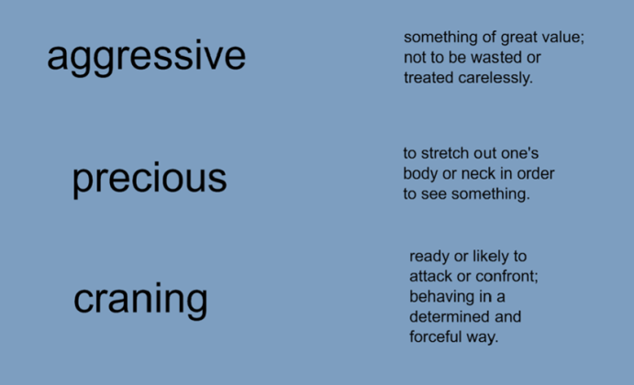
Quick definitions

Display definitions for a range of words for pupils to match up.
- You can add in an extra definition to make this challenging or two definitions which are very close but one that can be proven incorrect.
- This activity could be used as a quick fire activity on the whiteboard.

Synonyms & antonyms

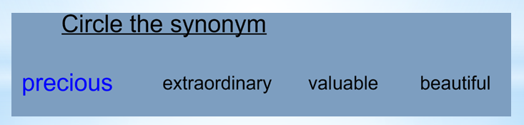
Give pupils chosen word with different possible synonyms/ antonyms. Pupils to circle/underline the word which is the best fit synonym/ antonym. The words that are selected should address any misconceptions pupils may have. For example, pupils may think that something ‘precious’ is something that is extraordinary and out of this world however, if they have a strong understanding of the word then they would be able to explain how they know it means something which is valuable.

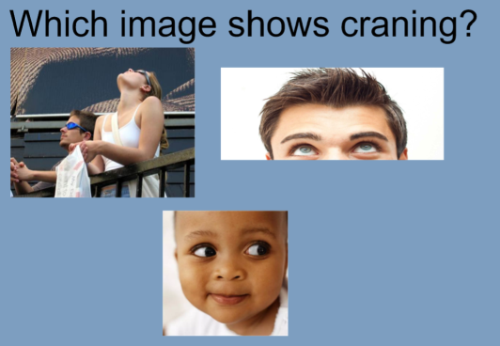
Match the word with images

Give pupils different images and ask them to choose which word shows the chosen word. The key is to find misconceptions and address them (similar to the activity above). Again, if pupils have a strong understanding of the definition, they will be able to choose the correct image.

Word association

Allowing pupils to make links between words is a powerful activity. Pupils can think of all the words associated to a topic or theme depending on the text. Pupils to map out all the words they have encountered or they may encounter. This enables pupils to activate their prior knowledge as well as expose them to new vocabulary.

Fastest finger

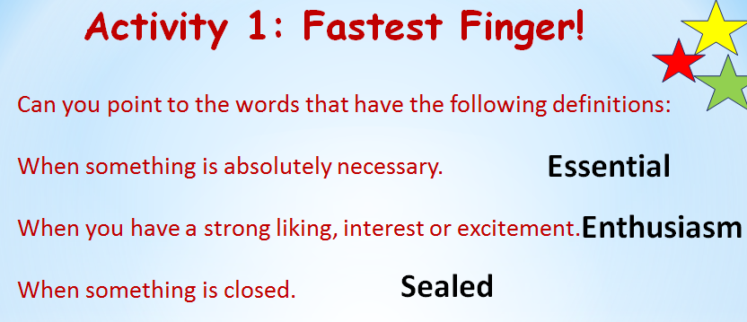
Pupil to practise skimming and scanning as well as exposure to words and consolidating their understanding of definitions. Display different definitions and pupils locate the word in the text.
- This could be used in the speed read sheet as a bingo activity.

Three in a row
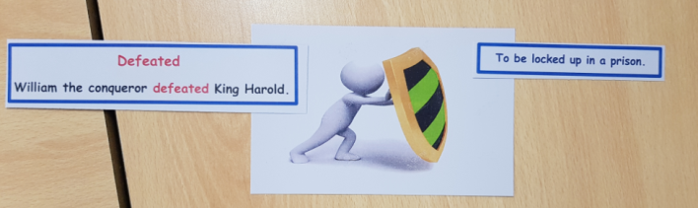
Pupils match an image, definition and the word together. Pupils must be given the word and the sentence in which the word was found so that it is context and helps them to read around the word for clues.

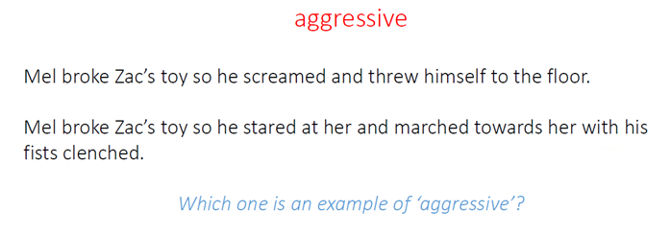
Example/ Non-example

Provide pupils with two sentences which are similar. Pupils to decide and explain which sentence shows the chosen word. If their definition of the word is accurate, they will be able to choose the correct sentence.

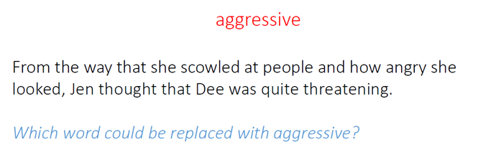
Replace the word

Provide pupils with a sentence and ask which word could be replaced with the chosen word. This activity helps pupils revisit the definition of the word but also widens the synonym vocabulary.

Making it stick
These kinds of activity allow the complexity and precision to be illustrated by placing the word in different contexts: some correct, some incorrect. But all this work will go to waste if children only encounter new words once. In order to keep new vocabulary on the boil, best practice is to place new words on cards in a word bank, which grows larger and larger as the year progresses. Then each day you can draw out a couple of words from your word bank so that over time, all words are revisited.
Semantic mapping
Semantic mapping of words helps us to see links and make connections between words: 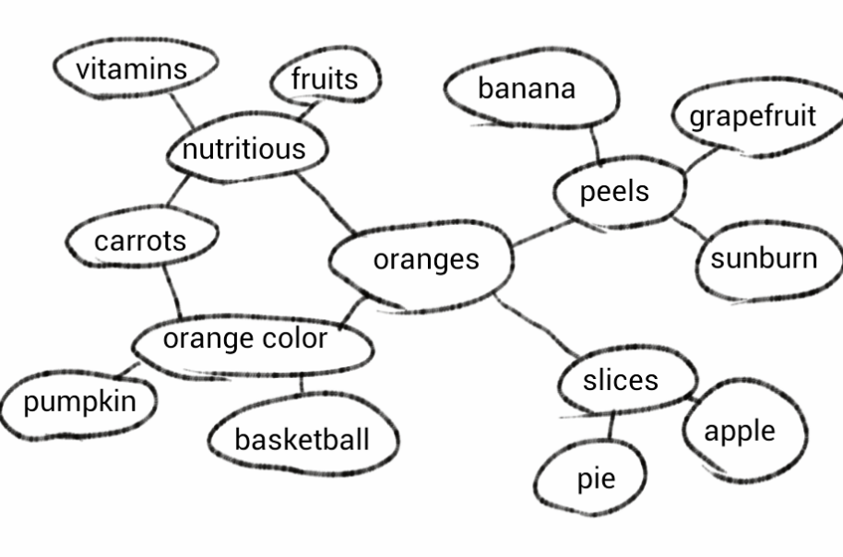
Examples of how words can be mapped:
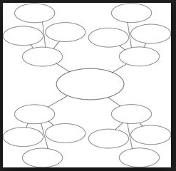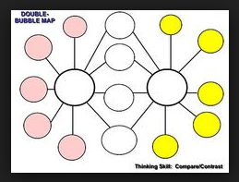
The double bubble is great to compare two words e.g. ‘ugliness’ and ‘beauty’.

Cause and effect semantic mapping above e.g. ‘beauty’ in the middle and what causes it going in and the effects it has coming out.

Lexipedia http://lexipedia.com/ , is a useful website that can support teachers/pupils to find exciting synonyms for words that you are learning in class.

Word table
Using more than one publisher if possible.
Find a variety of templates in the vocabulary journal folder in planning on common.
Target word | Examples of how the word is used in the text | Examples of where you have seen or heard the word being used before | What does the word mean in the text? What clues can you see? | Dictionary definition of the word | New examples

Games
Countdown corner: challenge to write the correct dictionary definition
Which definition? Two definitions on the board – one is correct and one is close to being correct. Which one is it and why? E.g. declaration.

Juxtapose words
For example: Can you make a hesitant declaration?
Can you be a kind bully?
Can you be a beautiful ugly person?

Find cognates
In linguistics, cognates are words that have a common etymological origin.
EAL children may show a strength in this area.

Visual word walls
Pinterest is good for this. We have made us a school login and started pinning underused words for us e.g. susurrus (whispering or rustling sound). Login to Pinterest: deputy@thameside.reading.sch.uk Password: Thameside2016

Vocabulary Ninja

Comprehension Ninja is designed to be a core part of your arsenal for teaching reading comprehension skills. Comprehension Ninja specifically focuses on the retrieval of information and word meaning questions using eight core comprehension skills that underpin the reading domains set out by the National Curriculum.
Each books contains 24 high-quality non-fiction texts that align themselves to the primary National Curriculum, the corresponding foundation subjects and subsequent topics taught within them. The first 12 should be used to teach the eight core skills associated with retrieval, while the last 12 provide both formative and summative opportunities to assess how pupils have progressed in each skill.
​Mastery of reading retrieval skills are the foundation of effective reading comprehension. Comprehension Ninja focuses on eight skills, labelling, matching, fill in the gap, multiple choice, true or false, find and copy, sequencing and underline/highlight questions. All of which, are essential in KS1 and KS2 statutory tests.

Fluency
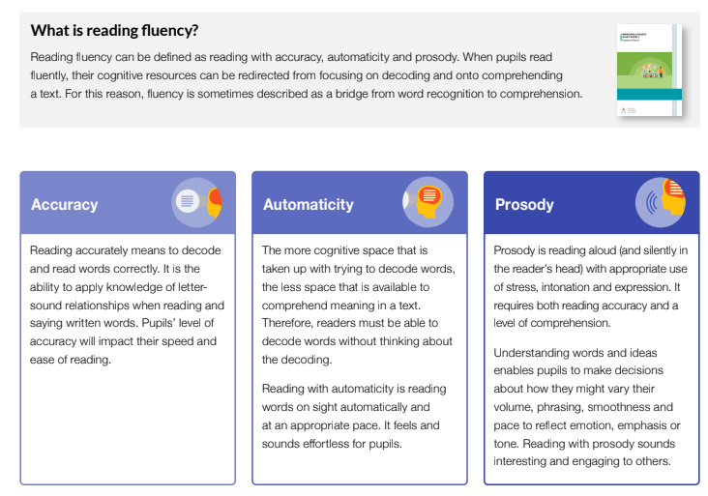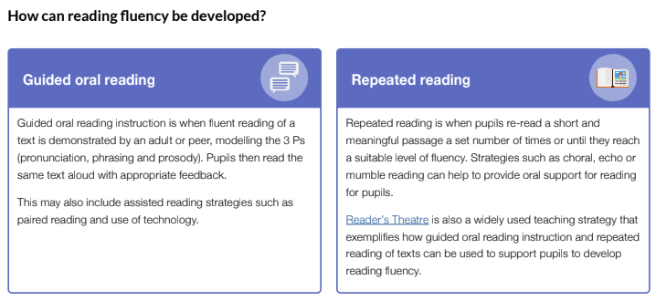

Teaching Fluency at Thameside
To begin each reading session children will have a reading fluency warm up, where they read an extract of a poem (at least 100 words) for 5 minutes to see how many words they can read accurately. The same poem should be used for a week to see how much their fluency increases over the week. The children are invited to take this poem home to practice. At the end of the week the children complete 3 SATs style questions to assess their comprehension of the text.

During Whole Class Reading Lessons, fluency is supported through regular choral reading, echo reading and paired reading.

For KS2 children who are not fluent in their reading, Readers Theatre will happen as an intervention:

Objectives:
Children can make inferences about characters and story events
Children understand how language contributes to meaning
Children will be able to evaluate their own and others' performances
Children will read accurately and fluently using appropriate rate, prosody, stress, phrasing, pausing and intonation

Starter: Warm up with reading part of a song! Or a Daily Word Ladder (for example)
Top tips: Don’t forget about poetry – it works really well at a text in Readers Theatre

A GUIDE to READERS THEATRE
Step 1: Adult as model  The adult reads the selected passage of the class text aloud as that expert model of fluency whilst pupils follow the text with their own copy. This may be repeated multiple times as necessary. | Step 2: Echo reading  Children echo back the section read by the adult, emulating their intonation, tone, speed, volume, expression, movement, use of punctuation etc. | Step 3: Text allocation  Children work in pairs or triads. Each group may:  1. all have the exact same short section of text, or  2. a longer section might be split into short parts, so that each group has a different piece.
Step 4: Repeated choral reading  In their groups children read their section aloud. Echoing the initial reading by the adult. | Step 5: Close reading  In their pairs/triads children make a close reading of their section of text and think about meaning, audience and purpose. This requires children to look closely at the writer’s use of language and consider characterisations etc. | Step 6: Text marking  Each child has a copy of the text to annotate in order to inform their performance. This is discussed and agreed as a group.  Prompts are provided to direct their reading.
Step 7: Practise  Time is provided for groups to rehearse their reading. They may decide to change or add to their performance slightly as a result of their rehearsal. | Step 8: Perform  Each group performs their rehearsed piece.  (Adult may record so that children can appraise their own performance). | Step 9: Reflect  Children evaluate their own and/or others’ performances and give feedback. They may use the fluency rubric or the prompts as success criteria to support articulation of evaluations. (These documents are saved on common)

Other information for teachers:

Select a section/chapter of the text. Children can all have the same short section or a longer section might be split into short parts, so that each group has a different piece. Teacher will read aloud the same section of text modelling fluency, intonation, movement, volume and expression whilst pupils follow the text with their own copy.

Explain to the class that you are going to adapt this section for Readers Theatre, where groups will take the same text and perform it for the class.
In each group of 2/3, there will be both characters and narrators - children may need to take on multiple roles.

In their groups children will make a close reading of their section of text and think about meaning. This requires children to look closely at the writer’s use of language and consider characterisations.
Provide a copy of the text for children to annotate, making notes (text marking) to inform their performance. This should be discussed and agreed as a group.
Give the children prompts to direct their reading.
Encourage children to reread their section of their text to give them time and opportunities to think carefully about the text and the language used by the writer.

Provide time for groups to rehearse their reading and to discuss.
They may decide to change or add to their performance slightly as a result of their rehearsal.
Encourage each group to perform their rehearsed piece.
Take digital images of children in role or video QR codes (for example).
Encourage the children to evaluate performances and give feedback to peers. Use the success criteria grid.
Use prompts to support articulation of evaluations: I liked it when... because... Model this for the class/group.

Source: https://researchschool.org.uk/shottonhall/news/how-i-teach-reading-fluency

More on Fluency

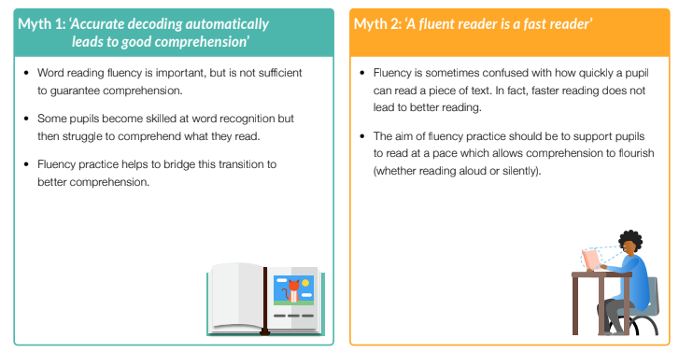

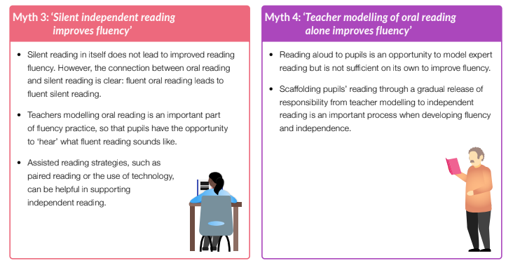

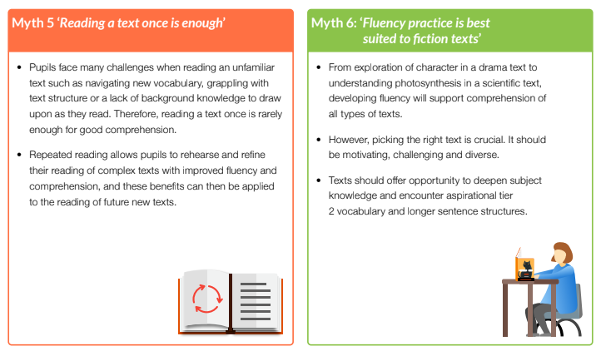

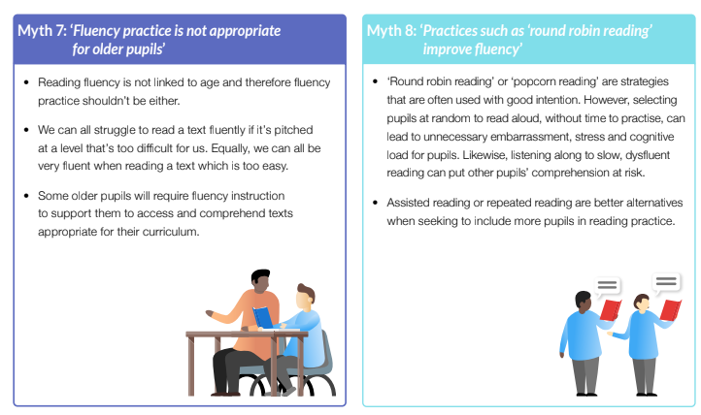

Fluency: the bridge from phonics to comprehension
Source: Herts for Learning 15 December 2020

‘Words mean more than what is set down on paper. It takes the human voice to infuse them with shades of deeper meaning.’
Maya Angelou – I know why the caged bird sings

Highlights, key learning and juicy tips!
- Begin each reading session with a fluency exercise (aka a song!). Why? It’s reading! When children sing a song with the words in front of them, they are accessing great material to develop their fluency. Also, children love to sing (as do most adults)!

- Make good use of poetry. Many poems are short and accessible and can do wonders to boost the confidence of weaker readers.

- Fluency instruction sits between word study and comprehension, hence the reference to it being a bridge. Some children can traverse that bridge by themselves, whilst others need a helping hand to get across. To begin the journey, children need a good foundation with words. Word Ladders are a great way for children to get playful with word-based learning, whilst at the same time bolstering their vocabulary knowledge. Resource: Daily Word Ladders (saved on common in planning, core subjects, reading)

- The goal of phonics instruction is to get readers to the point where they do not (consciously) need to use phonics! Aim for ‘automaticity’ – reading words with no apparent mental effort so that we are releasing mental resources for the task of reading comprehension.

- Phrasing matters - children who read words within sentences word by word will have a hard time extracting meaning. Pay particular attention to children who voice generic words e.g. prepositions, or perhaps determiners (for example, a child who reads the word ‘the’ in isolation from the words around it when there is no good reason for that emphasis).

Instructional tools for teaching fluency:
- Model fluent reading: in order to become fluent, you have to know what fluency sounds like. The answer lies in reading to our children.
  - Top tip: When discussing a text with the children, be sure not to just talk about the story/poem/text, but how it was read to them!
- Assisted reading: reading alongside the children in unison so that they can hear your voice and follow your lead.

- Practice:
  - Type 1: Wide reading practice – encouraging lots of reading of a range of different genres and text types. As opposed to little and often; aim for lots and often!
  - Type 2: Deep reading practice – repeated reading of the same text until adequate fluency is achieved.
  - Top tip: To encourage repeated re-reads, invite children to perform the text they have been practising to as many ‘Lucky Listeners’ as possible. Each Lucky Listener can sign the back of the text. PS. Dogs make great listeners (Cats? Not so much!)
- Focus on phrasing: Teach high frequency words within phrases, rather than as individual words (see point above about the word ‘the’). Use text marking to guide a phrased reading. Aim for the children to ultimately ‘perform’ the text without the text marking to guide them – by this point, the phrasing should be internalised.


Teaching reading fluency with the Seven-step model

Stage 1: Activating prior knowledge
This is a short and sharp part of the lesson designed to ​‘set the scene’ for the fluency practice. One favourite strategy is to ask quick ​‘show me’ questions using mini-whiteboards to recall the most important information from the previous chapter. Another is to write post-it note summaries of each chapter of our class novel to keep on a cumulative summary display. This way, lessons can begin with a rapid recap of ​‘the story so far’.
In my experience, a little and often approach to teaching the strategy of summarising is more beneficial than attempting to teach it as a discrete skill.

Stages 2 – 3: Explicit strategy instruction and modelling of learned strategy
Following the activation of prior knowledge, the teacher then reads the text aloud, modelling expert prosody. A passage will have been chosen for pupils to practise their own fluent reading.
Choosing the right text or extract here is key. It should be challenging enough that the pupils wouldn’t comfortably decode it independently, but a level of difficulty that’s attainable with teacher modelling and scaffolding.
In my school, we use the term ​‘performance reading’ to refer to a prosodic, meaning-laden style of reading. We regularly share the importance of practising this to train pupils to develop their own ​‘performance reading voice’.
Performance reading in my school is comprised of the 6 P’s:
- pace
- pitch
- pauses
- punctuation
- personality
- power
At this stage of the lesson, the teacher might ​‘cue the pupils in’ to what they should listen for (“I’m going to read a part of the story now where the characters are going into a scary new setting — pay special attention to the way I use pace and pauses to create tension”).
The teacher can then model reading aloud in a way that best illuminates the meaning of the text. This might involve a slightly slower than natural prosody, or giving extra emphasis to certain words or phrases, so pupils’ attention is drawn to salient parts of the text.

Stages 4 – 5: Memorisation of strategy and guided practice
What happens at this phase will vary depending on the age and experience of the pupils. At the simplest level, it might involve asking pupils ​‘what did you notice?’ or ​‘what happened to my reading when…?’ It may involve using echo reading to practise certain sentences or paragraphs.
With pupils who have had plenty of practice of performance reading, we might complete some text marking, annotating the text using an agreed code to show where extra emphasis is placed, to show rising or falling pitch, or to ​‘scoop’ words and phrases into clause or sentence units. This marked-up version of the text then acts as a guide for their own practice.

Stages 6 – 7: Independent practice and structured reflection
Pupils should now be ready for the challenge of decoding the text independently and with increasing fluency. They do this with a response partner: one pupil reads the text while the other listens and follows with a ruler. At the end of the extract, the listener offers feedback about what went well and what might be improved next time before the pupils swap roles.
The teacher’s role at this stage will vary. In the early stages of implementing fluency practice, they will need to ​‘be seen listening’, walking the room to listen and ensure that agreed routines are being stuck to. As the pupils become more familiar with routines, the teacher’s role can transition more to guiding practice and supporting pupils who might find reading difficult.
Pupils should be given time to practise their extract multiple times, aiming for greater fluency each time with the support of their partner. Partners should offer feedback on challenging words and phrases, using the language of the 6 Ps.
Research evidence indicates the promise of a focus on reading fluency, so these practical approaches, translated to the classroom can go a long way towards helping a greater number of pupils to ​‘cross the bridge’ to become accomplished readers.

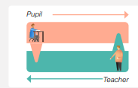

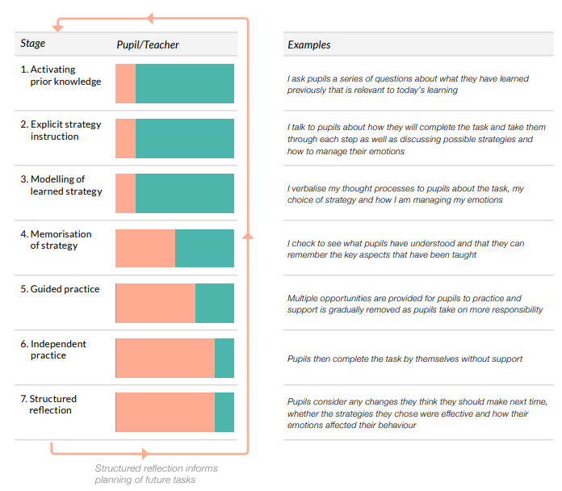

Accelerated Reader
At Thameside, children use a programme called ‘Accelerated Reader’ to monitor and facilitate their progress in reading.
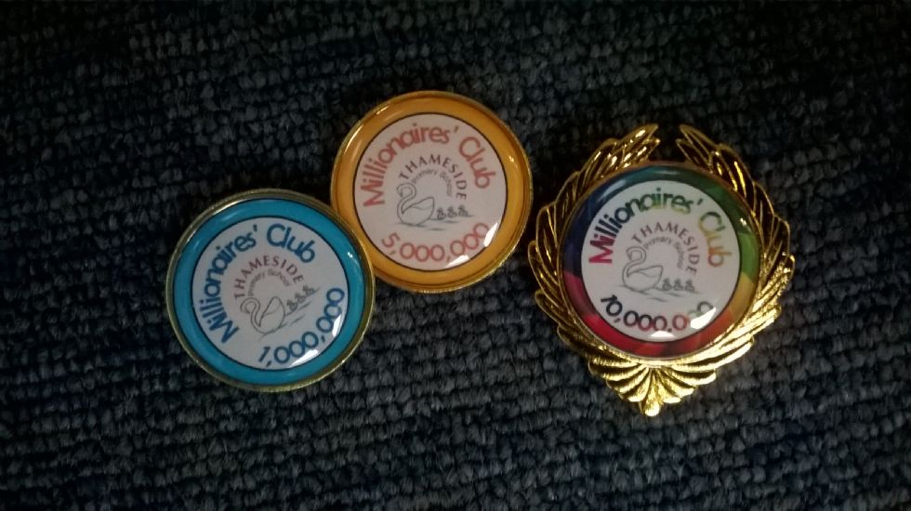
Step 1:
- Children take a Star reading test (at each assessment point).

Step 2:
- The teacher tells the child what ZPD range they should be reading for the next term. This range should be no more than 10 points

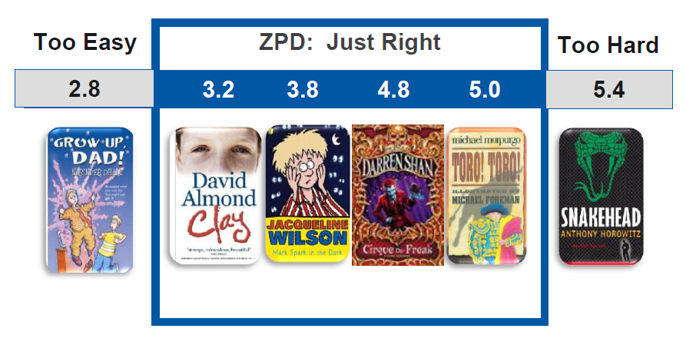
We also use AR to track word counts as children try to join our Millionaires’ Clubs!

Step 3:
- Children choose a book of the correct level and read it. They then log into AR, type in the book’s quiz number and click ‘search’.
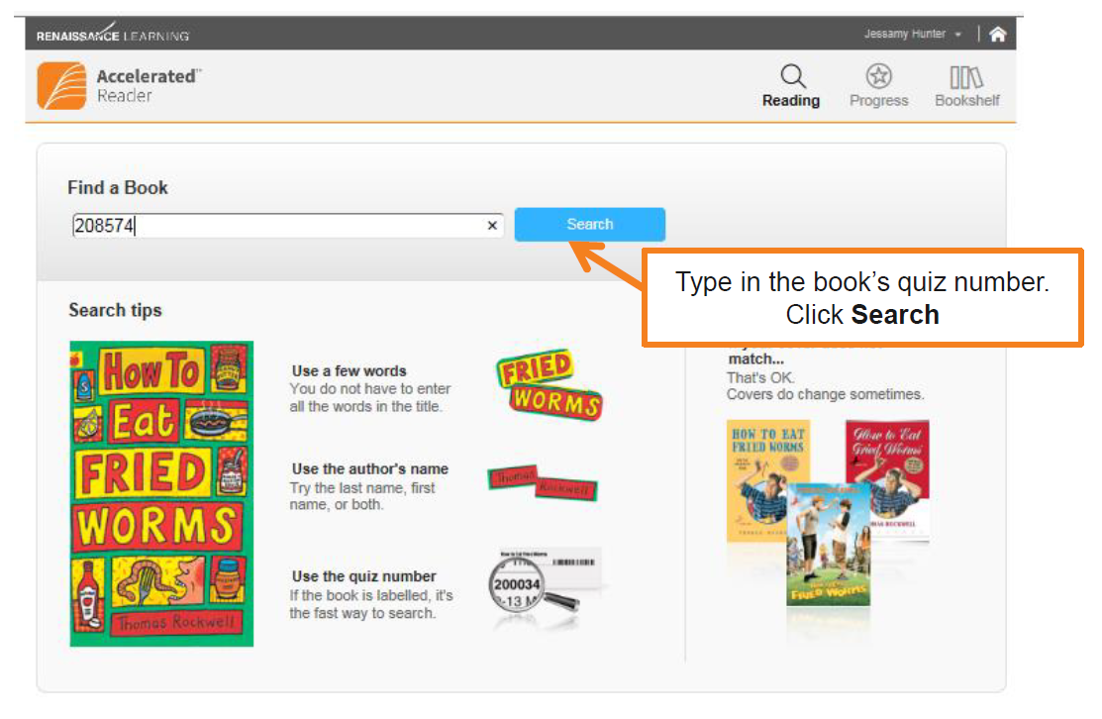
Step 4:
- They then take the quiz.

Step 5:
- Children read books of the same AR level and quiz and then choose another within their ZPD range. If you feel the child is ready to move up, do another Star Reader test to assess. Children must never be moved to a lower ZPD range.

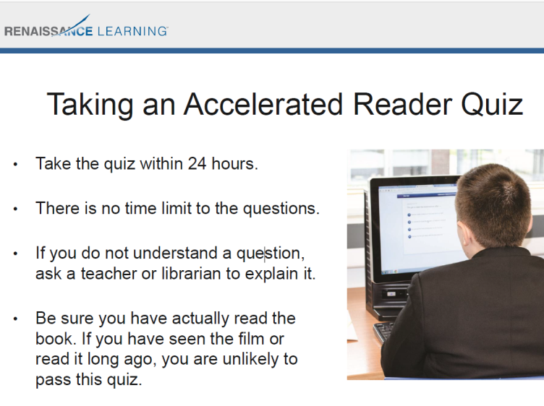
Teachers must monitor the progress and scores of their class through their AR logins.

Teachers must text parents to remind children if they are not reading and quizzing regularly.

Parents can do the same via Accelerated Reader link which they can access through the school website.
Once children are reading 7.0 AR books, they should be directed to specially selected books from the Purple Shelf in the library which contains books with a Lexile count of 1000+ to further support the reading development of able/confident readers. They can also ‘free read’ for pleasure.

Reading for Pleasure
Reading is rarely collaborative. So, whether preparing children for tests or not, we need to set them up to be independent readers – for future schooling and for their own pleasure. Studies have found that the amount of time students spent in independent reading was the best predictor of reading achievement. However, children shouldn't spend endless amounts of time reading without purpose; all reading in the classroom should be purposeful or should support children reading for pleasure.
To ensure children make progress in their independent reading, Thameside staff should ensure that:
- They are first able to fluently read the book that they are reading independently for pleasure (correct ZPD)
- Reading records are checked on a daily basis.
- All children have daily access to a wide range of books.
- Children are given at least 15 minutes of reading for pleasure time daily, where they are able to choose a book of their choice.

Benefits of reading for pleasure
A growing number of studies show that promoting reading can have a major impact on children and adults and their future. Upon reviewing the research literature, Clark and Rumbold (2006) identify several main areas of the benefits to reading for pleasure:
• Reading attainment and writing ability;
• Text comprehension and grammar;
• Breadth of vocabulary;
• Positive reading attitudes;
• Greater self-confidence as a reader;
• Pleasure in reading in later life;
• General knowledge;
• A better understanding of other cultures;
• Community participation; and
• A greater insight into human nature and decision-making

Class Reading Scrapbook
Each class has a reading scrapbook to encourage them to share books they have enjoyed and would like to recommend to their peers. They should include the author and other books by the author, why they like the book and their favourite part of the book. They can include a drawing such as recreating the front cover or an illustration of a character. These are a great way to promote reading for pleasure. Each week a child is selected to complete a double page spread about a recent book they’ve read. The children must then be given an opportunity to present it to the class.
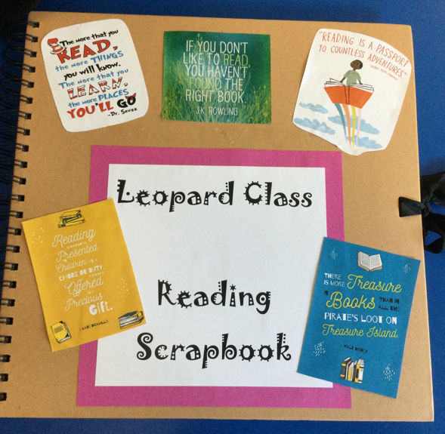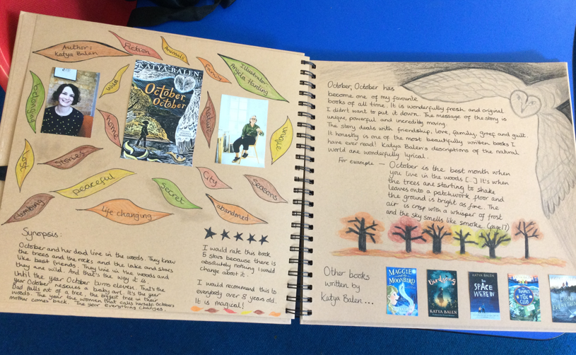

A wide range of texts
We need to ensure that children read widely. Anything with printed or spoken words, films and pictures are all fair game for a reading lesson. Pairing a fiction and a non-fiction text (for example: The Snow Goose and Circle in Year 6) can increase understanding of the fiction text and give more contexts for the non-fiction text. It's also a great way to provide opportunities for discussion of other issues, from world affairs to grammar and punctuation use.
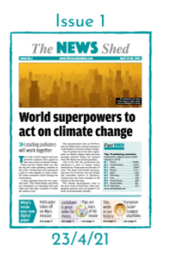

The News Shed
Our subscription to the Literacy Shed includes access to its News Shed.
https://www.literacyshedplus.com/en-gb/browse/the-news-shed


We pay for membership to the Literacy
Shed +
Username: Thameside1
Password: Torday55

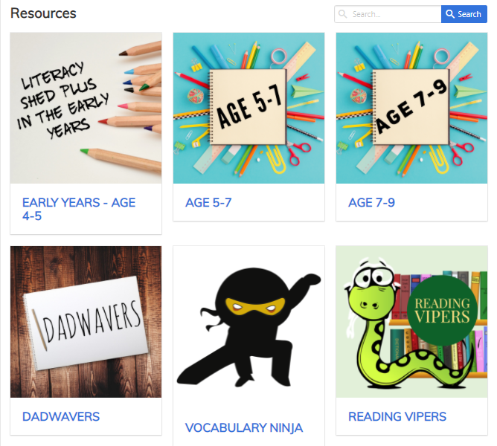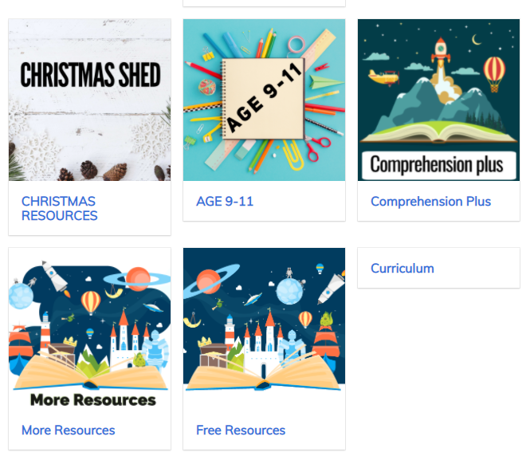

Teachers are encouraged across the school to use the films and other teaching resources available on The Literacy Shed Plus.
It is a website for teachers filled with ideas for literacy teaching using visual resources such as film, animation, photographs and picture books.

Book corners/reading displays
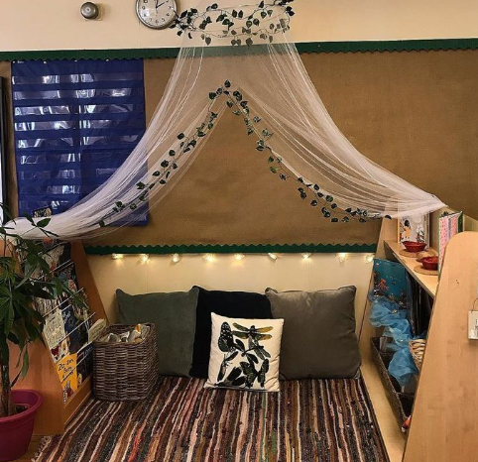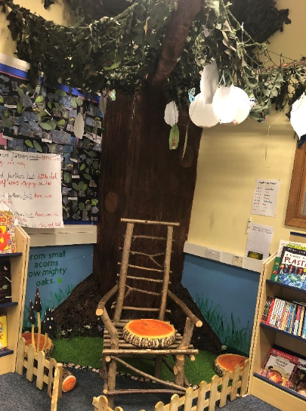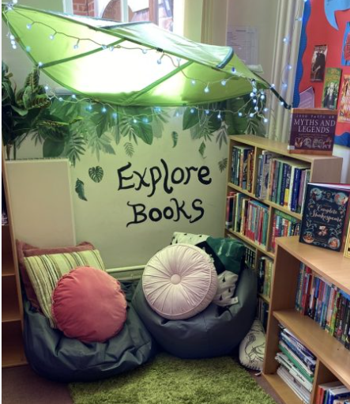

Make sure your classroom promotes reading!

- Think simple but effective!
- Choose a cosy corner to the back of your room.
- Have books out for children to read linked to the topics you are teaching e.g a table/display on Stone age with some linked items and books to promote reading across the curriculum (we have topic boxes of books in the upstairs big group/PPA room
- Have the 3 books that are on your spine that term e.g. English book, whole class reading book and class reader displayed at the front of your room (on forward facing book holders)
- Promote books by the same author or illustrator of the book your class are studying
- Recommend books with similar themes, settings and characters: ‘If you liked this book, you might also like ...’
- Promote other teachers’ and pupils’ suggestions of books to read
- Our Learning to Comprehend lesson sequence ends with an oral book recommendation, some of which could be written up by teacher/TA and shared in your book corner or added to your scrapbook.
- Read/display a teaser from a book that you will be reading soon
- Remind pupils of the books that you have already read e.g. photocopies of front covers so can refer to these in lessons to support pupils to make links to prior reading
- Book areas should be well looked after.
- Ask your boys about your book corner – does it encourage them to read books? If not, what would they like to see?
- Book corners should have questions to make children think about the texts they are reading.

DfE…

Library
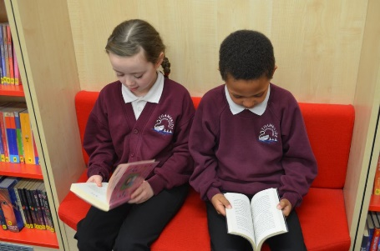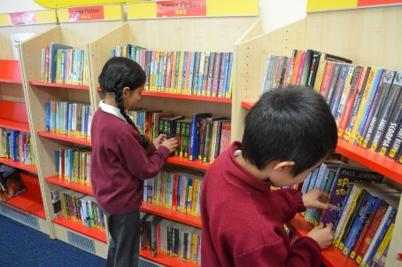

We have over 4000 up-to-date children's books in our library, both fiction and non-fiction and covering a wide range of interests and reading abilities. We’d like all the children to have the very best opportunity to make the most of what our library has to offer, so here is some information that we hope will be useful:
- Each class has a weekly timetabled visit to the library. Please make sure your child brings his or her library books into school on library day so they can be exchanged for new ones.
- Once a week after school (until 4.00 pm) we have a special time for parents/carers and children to visit the library together, either to borrow books or simply to browse and read. We can also give advice on reading choices. Children and parents are all welcome to come along whenever they can.
- Please ensure your library slot is being used to give children regular access to the library.
- Please ensure the library is being used by your class to support their learning in other subjects e.g. research in topic lessons.

Cross curricular links
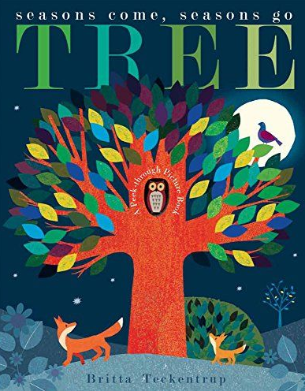www.booksfortopics.com

Books to support learning of knowledge in topics/other subject areas are used in Assemblies and Foundation Subject lessons and promoted in class.

- Please ensure reading skills are being applied in other subjects and this should be evident in books e.g. topic, science
- Librarians can produce a box of books for the topics you teach, so long as you give plenty of warning in advance.

Reading Support
- Progress tests (or mock SATs) and Star Reading assessments used to inform assessment points.
- RWI 1:1 tutoring or Fast Track Tutoring
- Ensure children have access to Nessy (if they have a subscription)
- Use Nessy worksheets, as left hand page word work, to consolidate children’s learning on the computer programme.
- See the Assistant Head of Inclusion or an Assistant SENDCO if you have a particular concern about a pupil’s reading abilities (Assistant Head of Inclusion or an Assistant SENDCO to carry out WRAT test and possible interventions).
- Please consider that children will learn best when they read regularly with the teacher
- Teachers use reading/peer coaches to support reading.
- Symwriter to support SEND children with their reading in lessons.
- 1:1 daily reading for target children
- Weekly catch-up tuition sessions for selected children
- Audio books used for some children

Homework
- Across the school, there is an expectation of at least 10 minute a night of ‘Independent Reading’, which teachers must support and ensure happens. Teachers should text reminders home if this is not happening and discuss at parents evening.



Enhancement
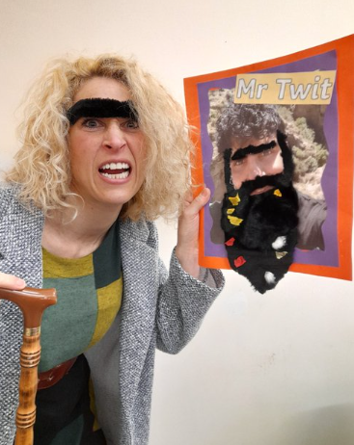

- We celebrate World Book Day, World Story telling Day and hold an annual Book Week and expect teachers to be positively involved in these events
- We hold a KS2 poetry slam
- Thameside writes its own whole school book each year
- We have a central display on a book each big term
- We learn about the authors of books and try to invite them into school, where possible
- We use books as the focus of our annual Number Day
- Books are used in all subjects to support children’s learning in a wide range of subject areas
- Teachers support our termly reading challenges to raise the profile of reading in the school.
- Teachers use the story telling chair to read outside to children
- Children are encouraged to do read as much as possible in lessons e.g. off the IWB, or sheets instead of the teacher.
- We invite parents, who can speak other languages, to come into school to read stories to the children.
- Children know that their teachers love books
- Books are the focus of nearly all of the HT’s assemblies
- We celebrate our achievements on social media and run reading workshops for parents to keep them informed.
- Enrichment activity days focus on books.
- We take part in the annual Henley Literary Festival
- We have regular virtual and in person author visits

S Greenaway / S Cooper /C Calvert
July 2026

