YEAR 5 - History – Ancient Egypt
Key Vocabulary |  |  | Key Person | Key Texts
Pyramid: structures built in Ancient Egypt as monuments and tombs for Pharaohs  Pharaoh: The most important and powerful person in Ancient Egypt; considered to be half man and half god  Sphinx: a mythological creature with the body of a lion and the head of a human  Nile River: The river that runs through Egypt; it is the longest river in the world  Valley of the Kings: an area of land in Egypt that contains the tombs of many Ancient Egyptian rulers | Hieroglyphics: a form of writing that uses pictures and symbols instead of letters and words  Archaeologist: a person who studies history by digging up objects  Artefact: a man-made object that is of historical, cultural or archaeological significance  Mummification: a method of artificial preservation, stopping the skin and flesh from decaying  Sarcophagus: a stone coffin used to bury wealthy people in Ancient Egypt |  | 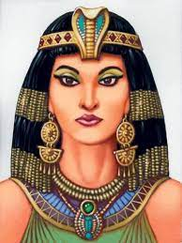  Cleopatra  She was the last active ruler of Ancient Egypt and she had a great influence over Ancient Rome politics. | 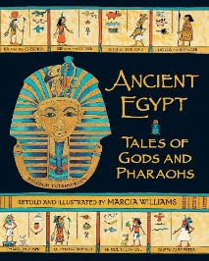  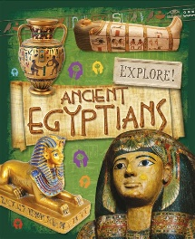  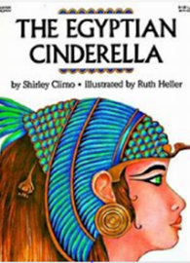  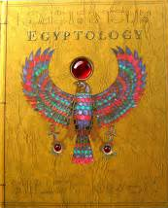
Map of Ancient Egypt |  | Five Key Facts!
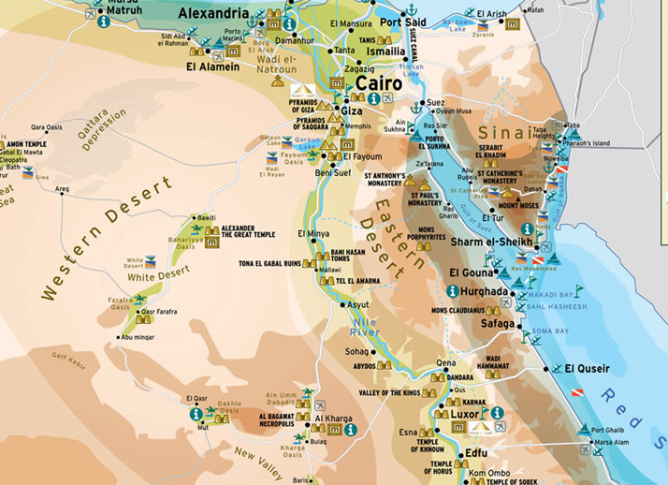 |  | - It is believed that Ancient Egypt suffered 10 plagues because the Pharaoh refused to set the Israelites free so God sent the 10 plagues as punishment.  - The Ancient Egyptian period lasted around 3000 years - roughly 3150BC to 30BC.  - Treasure was buried with the Pharaohs to help them in the afterlife and they believed that mummifying someone would make their soul live on forever as they were being preserved.  - There were over 2000 Ancient Egyptian Gods and Godesses.  - The Ancient Egyptians invented a lot of things that we use today (e.g. medicines, paper, locks, keys, toothpaste)

