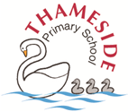
YEAR 6 - SCIENCE – INHERITANCE
Key Vocabulary |  |  | Key Figures
Inherit: traits passed from parent to offspring  Genes: your genetic make-up  DNA: the carrier of your genetic information  Chromosome: 23 pairs are found in every cell of the human body  Characteristic/Trait: a feature or quality belonging to a person  Inherited characteristics: traits you inherit from your parents |  | Environmental characteristics: how you are influenced by those around you  Dominant Genes: the gene most likely to be inherited from parents, e.g. brown eyes  Recessive Genes: the gene least likely to be inherited from parents, e.g. blue eyes  Identical twins: twins of the same gender who look similar in appearance as they grew from the same egg in the womb  Fraternal twins: twins grown from separate eggs, can be different genders | 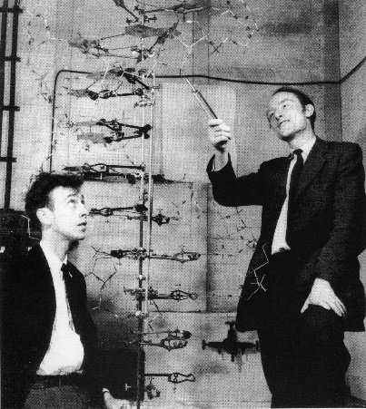  James Watson and Francis Crick  Determined the double-helix structure of DNA, the molecule containing human genes.
Structure of DNA | Five Key Facts!
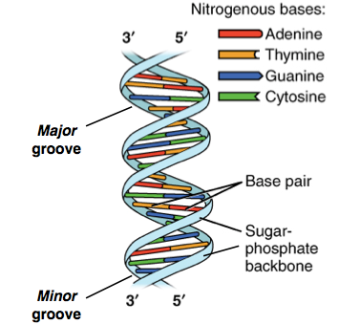 | - Inheritance is the process by which genetic information is passed on from parent to child. This is why members of the same family tend to have similar characteristics.  - We have 46 chromosomes in every cell in our body (23 from each parent).  - An Inherited Characteristic could be: eye colour, hair colour, height, bone structure, nose shape etc  - An Environmental Characteristic could be: music taste, languages spoken, personality, diet etc  - Some diseases can be inherited from our biological parents such as: heart disease, arthritis, diabetes etc

