YEAR 6 - HISTORY – TUDORS
Key Vocabulary |  | Five Key Facts! | Key Figures
Monarch: a leader or ruler of a country  Reign: the period of time that a monarch rules a country  Heir: the next in line to rule  Treason: to betray your monarch or country  Execution: being put to death, often beheading | Gallows: a structure used to hang people  Jousting: a medieval sporting contest between Knights on horses with lances  Breeches: short trousers worn by men  Sanitation: conditions of water/sewage  Heritage: property/items to be inherited | - The Tudors began after the end of the War of the Roses when Henry VII (Lancaster) became King and married Elizabeth (York).  - The Tudor period was between 1485 and 1603.  - Tudor houses are very distinct. The houses had a wooden frame with walls made from “wattle and daub” – a building material consisting of wooden strips covered with mud and clay.  - Henry VIII is the most famous Tudor royal for his desperate desire for a son to become his heir.  - There were many fatal diseases such as Smallpox, the Plague and the Sweating Sickness | 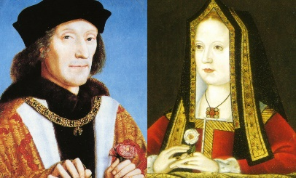  King Henry VII and Elizabeth of York – they married and created the Tudor dynasty  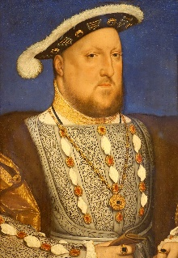  Henry VIII  Famous for having 6 wives, he ruled from 1491 to 1547.  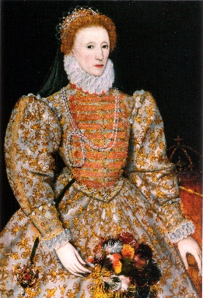  Elizabeth I  Henry VIII’s daughter by Anne Boleyn, she reigned for 45 years.
Timeline of Key Dates
